Math 116  Dusty Wilson  Review: Chapter 7 | Names: ____________________________

Part 1

- By hand, graph and convert the
equation to rectangular coordinates.

- Let and .

  - Find .

  - Find .

- Use De Moivre’s theorem to evaluate . Give the exact answer in rectangular and polar form.

Math 116  Dusty Wilson  Review: Chapter 7 | Names: ____________________________

Part 2

- A tree growing on a hillside casts a 100 ft shadow straight down the hill. Find the vertical height of the tree if, relative to the horizontal, the hill slopes and the angle of elevation of the sun is .

- Solve the triangle to the right when and .
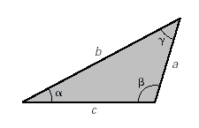

- Vector has magnitude and direction . Vector has magnitude and direction . Find the magnitude and direction of .
- If , , and .

  - Find .

  - Find a unit vector with the same direction as .

- Find all solutions to .

9. By hand, graph .

