Math 115: The Perfect Route

Part II

80 points.

The Scenario: During the film, “The Hunt For Red October,” the Soviet fleet dispatched their entire navy in a last minute effort to stop Captain Marco Ramius from defecting to the United States of America. A little known fact about the situation is that Nikolai Rostov, the Captain of a Soviet Alpha Class submarine, navigated just below the surface of the water to within a few short miles of the Red October. All that stood between Captain Rostov and the Red October was Rakhat Canyon, which contained two American sonar buoys. Unfortunately, these obstacles were too much for Captain Rostov and he was forced to turn around. As the years passed, Captain Rostov has looked back on that moment with great bitterness. For in his mind, it marked the beginning of the fall of the Union of Soviet Socialist Republics.

Now, the American fleet plans to make a mockery of Captain Rostov by using Rakhat Canyon as a training ground for rookie sub commanders. Their modern technology will allow them to program a function into their navigational system, thus allowing the ship’s computer to navigate the route that Rostov’s vessel could not navigate through manually steering.

The Assignment: As one of the new sub commanders, you are to calculate a possible route through Rakhat Canyon. Mathematical models for the canyon walls are given below where R(x) models the right wall of the canyon and L(x) is the left. Additionally, you must find a route that avoids the two sonar buoys located at the coordinates (-3.2, 7.5) and (3.1, 4.2) where the first buoy has a range of twelve hundred meters and the second a range of two thousand meters. The variable x measures the distance east from the origin as it is shown on the map on page two. Each unit represents one thousand meters.

$$R(x)=\frac{1}{\text{20}}(x−5\text{.}\text{11412})(x−2\text{.}\text{05893})(x+6\text{.}\text{17305})$$ | $$L(x)=\frac{1}{\text{20}}(7+x)(\text{22}−7x+x^{2})$$

The Procedure: Using the mathematical tools available to you, you are to find a continuous function (not a piece-wise function) that safely navigates Rakhat Canyon. In the process of finding the perfect route, you may well propose many routes that do not suit your purposes. This is to be expected – keep trying. Victory comes with perseverance.
4.) (10 pts, due 02/04). In the process of finding the perfect route, you will (most likely) propose many routes that do not suit your purposes. You are to submit one such route (function). Along with this route (function), please describe a reason why this route failed. That is, if your route came in contact with the right canyon wall, you are to write: “My route f (x) came into contact with the right canyon wall.” Then you are to include a computer generated graph that shows the canyon walls, the “danger zones” of the sonar buoys, and your failed route with the place of failure well marked and labeled with its x and y coordinates.
5.) (20 pts, due 02/11). Submit a route that successfully navigates the canyon and all of the obstacles. In addition to the function, submit a graph of your route similar to that described in the previous part. You also must submit the graphical proofs that your route successfully navigates all obstacles. These proofs are 4 separate well-labeled graphs similar to that described in part 2, section ii. The four graphs are of two different kinds: (a.) one graph for each “danger zone” and (b.) one graph for each canyon wall.

Write-Up: Your final product is to be a typed write-up that includes: (1.) a cover sheet, (2.) a description of the situation, (3.) your conclusions after completing your training as a submarine commander. (Feel free to make this entertaining), (4.) your final route, (5.) proof that your route successfully navigates Rakhat Canyon (all graphs must be computer generated), and (6.) the minimum distance from the sub to each of the two sonar buoys.
6.) (40 pts, due 02/19). Submit the final project. Your write-up should be as described in the project description. It should contain college level writing and Pre-Calculus level mathematics. I will also ask for an evaluation of the other students in your group. This evaluation will be a portion of your final grade.
7.) (10 pts, due 02/19). Evaluate the overall effectiveness of the group as well as your fellow two group members. Use the attached evaluation form.
Note: In your final project, there will be three main components: the route, the proofs, and the write-up. It is my goal as an instructor to reward each of these portions in a semi-equal manner. Thus, each of these efforts will be rewarded, but no one or two parts are satisfactory without the third. Do your work casrefully, do not procrastinate, and ask questions. Good luck;-)

Bonus Question: Name the sources that inspired the names Nikolai Rostov and Rakhat Canyon. (Better yet, spend the time to get to know the sources.)

The Map Below shows Rakhat Canyon
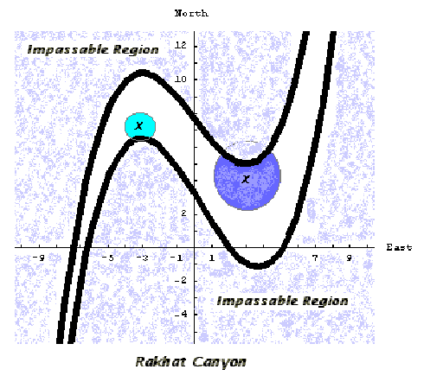

It should be noted that the east/west domain of the canyon walls are fixed and that this domain may be found given a range of {y | -6 ≤ y ≤ 13} for each canyon wall.


