A set of vectors  is called an __________________ _______ if each pair of distinct vectors from the set is orthogonal. That is, ____________ when .

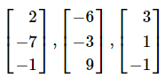Determine whether the set of vectors is orthogonal.

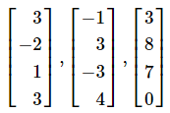

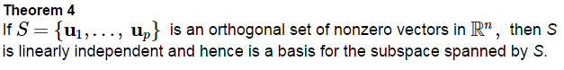

Proof:

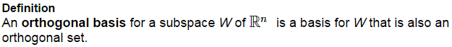

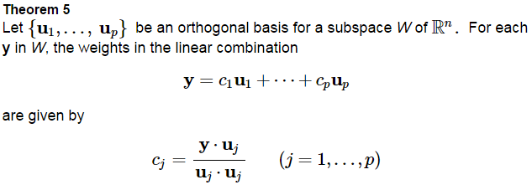

 The vector  is in the subspace *W* with orthogonal basis from Ex 1b). Express **v** as a linear combination of the orthogonal basis.

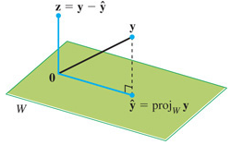**An Orthogonal Projection**





Then write  as a sum of two orthogonal vectors. Also, observe geometrically.

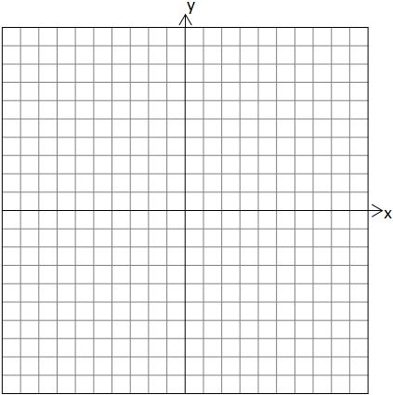

Find the distance from the vector to the line through  (from Ex 3).

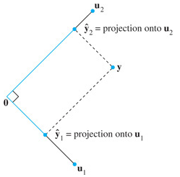Notice that the orthogonal projection formula matches the weights of the orthogonal basis terms in theorem 5. Theorem 5 decomposes a vector into a sum of orthogonal projections onto one-dimensional subspaces (lines).

In , if we have an orthogonal basis   
then any  can be written as



In physics we use this to decompose force on an object.



A set of vectors  is called an _______________________ _______ if it is an orthogonal set of ______________ _______________. If *W* is spanned by this set, then the set is an _____________________________ _______________ for *W*.

The simplest orthonormal basis for is { }.

Any nonempty subset of this standard basis is orthonormal as well.

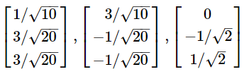Determine whether the set of vectors is orthonormal. Is it an orthonormal basis for ?



Proof:

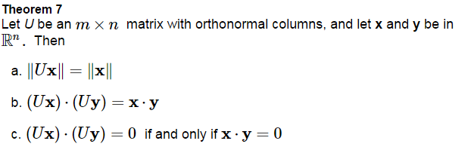

Let  and . Verify that 

An _______________________ ________________ is a square invertible matrix , such that . By theorem 6, it has orthonormal columns.

The matrix formed from the vectors from Ex 5 is an example.

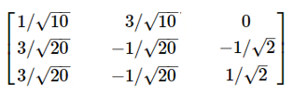

**Practice Problem**

1. Let U and **x** be as in example 6, and let . Verify that 