We are now going to look at converting a vector x in one coordinate system into another coordinate system – same vector, different coordinate representation.

Consider the following vector spaces spanned by  and  respectively.

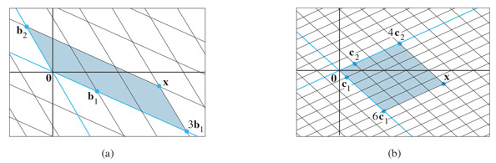

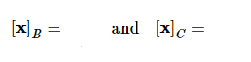  
  
By observation, find



  
Suppose (that is, ), find .

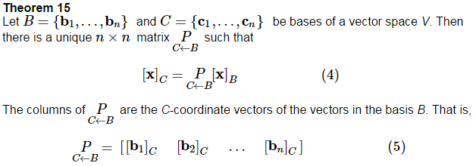

is the ___________________________________________________________

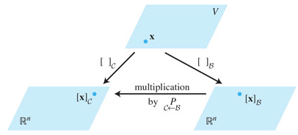



Why are the columns of linearly independent?

So  is _________________________.

So equation (4) above can be re-written as

Since is the matrix that converts *B*-coordinates to *C*-coordinates, what should

 do?



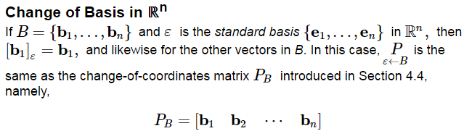

However, to change coordinates between two non-standard bases in , we will need to use Theorem 15, and find coordinate vectors of the ________ ____________ relative to the _________ _____________.

 