**Math 220  
6.2: Orthogonal Sets  
Questions for flipped class**

**Important terms**Basis vs orthogonal basis vs orthonormal basis:  
  
  
  
  
Matrix with orthonormal columns vs and orthogonal matrix.

**Baby Mode**

(6.2.1)

Show that is an orthogonal basis for . Then express  as a linear combination of the 



(6.2.2)

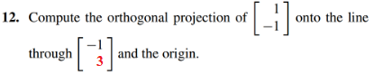

(6.2.3)

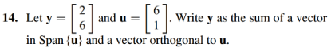

**Community college material**

(6.2.4)

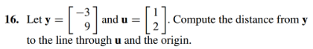

(6.2.5)

There are two sets of vectors below (line 1 and line 2). Determine which sets of vectors are orthonormal. If a set is only orthogonal, normalize the vectors to produce an orthonormal set.

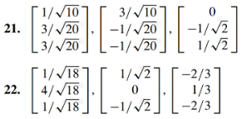

**Ready for university!**

(6.2.6)

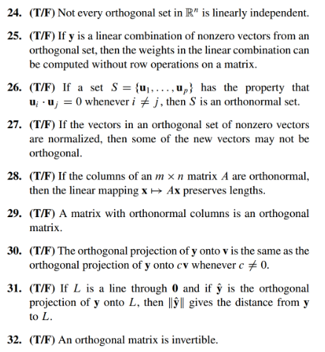

**Important terms**Basis vs orthogonal basis vs orthonormal basis:

|  |  |  |
| --- | --- | --- |
| **Basis** | **Orthogonal Basis** | **Orthonormal Basis** |
| Linearly independent | Linearly independent | Linearly independent |
| Spans | Spans | Spans |
|  | Vectors are all orthogonal | Vectors are all orthogonal |
|  |  | Unit vectors |

Orthogonal projection:



An orthogonal matrix U is a square matrix where U inverse = U transpose

(6.2.1 solution)

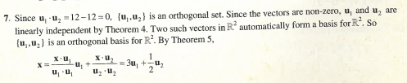

(6.2.2 solution)

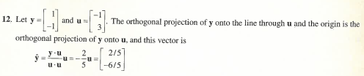

(6.2.3 solution)

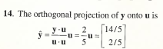 <------ Issue with this solution

(6.2.4 solution)

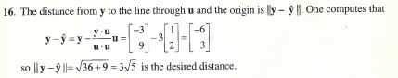

(6.2.5 solution)

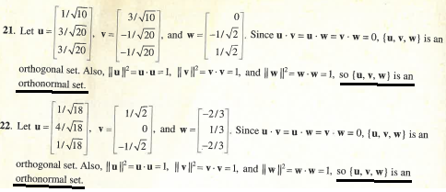

(6.2.6 solution)

