**Math 220  
6.1: Inner Product, Length, and Orthogonality  
Questions for flipped class**

**Important terms**Orthogonal projection:  
  
  
  
  
:

**Vectors are powerful tools for certain basic calculations**

(6.1.1)

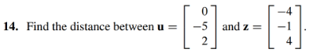

(6.1.2)



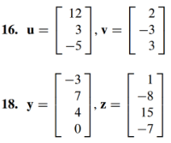

**Are you sure that orthogonal vectors are normal?**

(6.1.4)

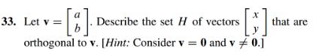

(6.1.5)

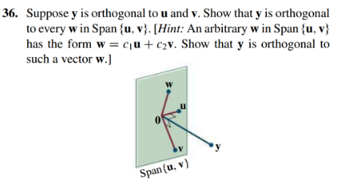

**So … in “theory” the structures that I have built have been appropriately orthogonal**

(6.1.3)



(6.1.6)

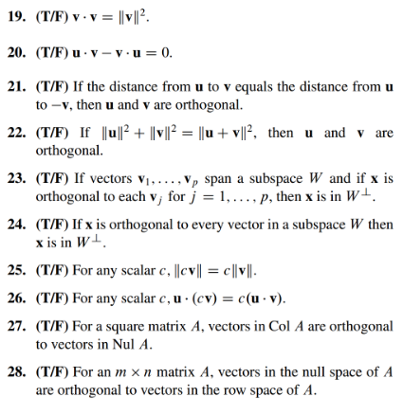

(6.1.1 solution)

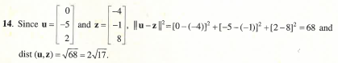

(6.1.2 solution)

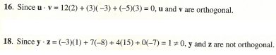

(6.1.3 solution)



(6.1.4 solution)

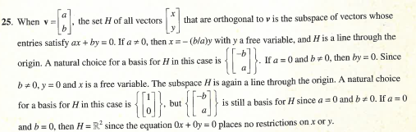

(6.1.5 solution)



(6.1.6 solution)

