**Math 220  
5.4-6: Dynamical Systems  
Questions for flipped class**

**Important terms**Multiply right to left

Matrix powers and dynamical systems

**Feel the power!**

(5.4.1)

Suppose  and . Find a closed-form expression for  by first writing  in terms of the eigenbasis.

**Fight the Power**

(5.4.2) Suppose we have the transition matrix and initial state . Find a closed-form expression for  and then find the steady-state/equilibrium vector .

**Could things get more complex?**

(5.4.3) Sketch phase portraits for the previous two questions that account for their eigenvalues and eigenvectors. How would we describe each dynamical system?

(5.4.4) Suppose , find invertible *P* and rotation-scaling matrix *C* such that . What is the scaling factor and what is the angle (in degrees) of the rotation.

(5.4.5) Suppose  and  where  and .

Find a new invertible *P* and rotation-scaling matrix *C* such that . What is the scaling factor and what is the angle (in degrees) of the rotation.

Sketch the rough trajectory of  if 

(5.4.1 solution)

(5.4.2 solution)

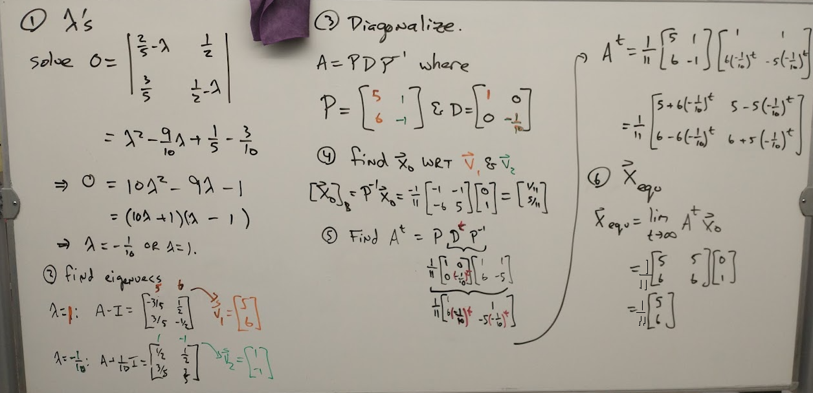

(5.4.3 solution)

(5.4.4 solution)

(5.4.5 solution)