**Math 220  
5.2: The Characteristic Equation  
Questions for flipped class**

**Important terms**Characteristic polynomial:  
  
  
  
  
Similar matrices:

**For the masses**

(5.2.1)





(5.2.2)

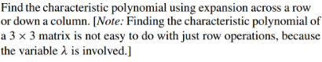

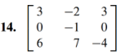

**Drill and kill precedes the thrill of skills**

(5.2.3)

Find the characteristic polynomial and eigenvalues of:



What is the algebraic multiplicity of the eigenvalue(s)?

(5.2.4)

Find the characteristic polynomial using expansion across a row or down a column.

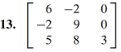

Use this to find the eigenvalues and their algebraic multiplicity

(5.2.5)

Find (1.) the eigenvalues, their (2.) multiplicities, and (3.) the corresponding eigenspaces.

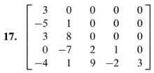

**A little theory is like vitamin D during a gray Seattle winter**

(5.2.6)

Assume *A* and *B* are *n* x *n* matrices

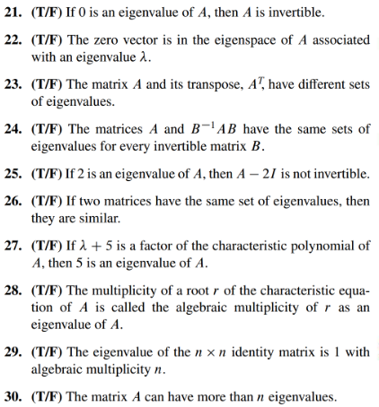

(5.2.1 solution)

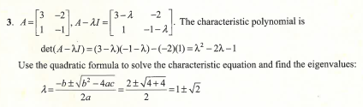

(5.2.2 solution)

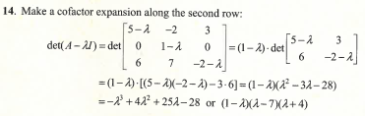

(5.2.3 solution)

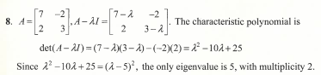

(5.2.4 solution)

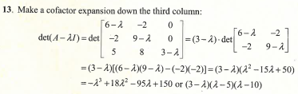

(5.2.5 solution)

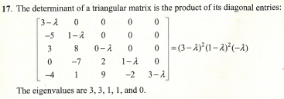

(5.2.6 solution)

