**Math 220  
5.1: Eigenvalues and Eigenvectors  
Questions for flipped class**

**Important terms**Eigenvectors identify:  
  
  
  
  
Eigenvalues identify:

Pronounced: sort of like again: uh-ghin vs eye-ghin

(5.1.2)

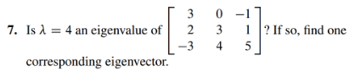

**Eigen – what?**

(5.1.1)

(5.1.3)





(5.1.4)



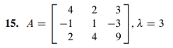

**Today would we call it an iGen Vector?**

(5.1.5)

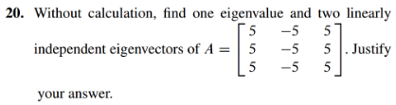

(5.1.6)

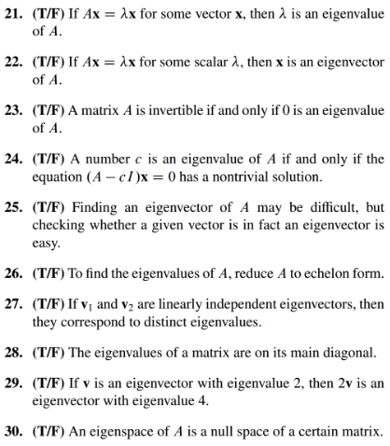

From Wikipedia: Eigenvalues and eigenvectors feature prominently in the analysis of linear transformations. The prefix eigen- is adopted from the German word eigen (cognate with the English word own) for 'proper', 'characteristic', 'own'.[6][7] Originally used to study principal axes of the rotational motion of rigid bodies, eigenvalues and eigenvectors have a wide range of applications, for example in stability analysis, vibration analysis, atomic orbitals, facial recognition, and matrix diagonalization.

From the Google and tied to data analytics: Eigenvalues and eigenvectors can be used to extract the most important features of a dataset by identifying the directions of maximum variation in the data. These directions can be represented by the eigenvectors, and the amount of variation in each direction can be represented by the corresponding eigenvalue.

(5.1.1 solution)

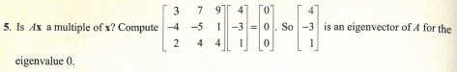

(5.1.2 solution)

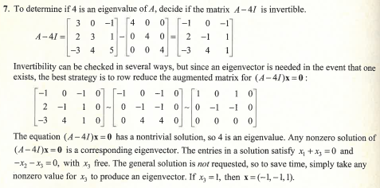

(5.1.3 solution)

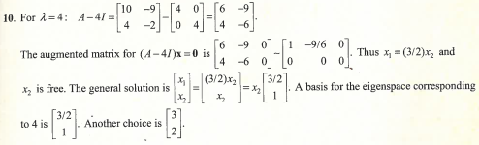

(5.1.4 solution)  
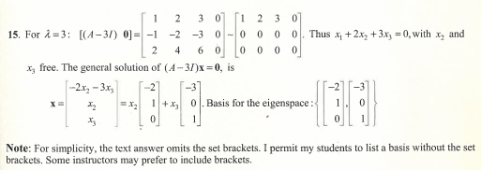

(5.1.5 solution)

Note: This solution doesn’t quite match as the A matrix students worked with includes a column of negative fives,

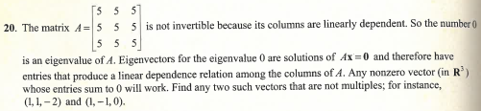

(5.1.6 solution)

