**Math 220  
3.1&2: The Determinant  
Questions for flipped class**

**Important terms**Diagonal  
  
  
  
  
Upper and lower triangular matrices

Uses:

* Determine if Ax = b has a unique solution
* determine if A has an inverse
* find short cut formulas for solutions

Visualize: We envision the determinant as the scaling factor of a linear transformation

**Practice calculating determinants by hand**

(3.1.1)

Calculate the determinant (calculated by hand)

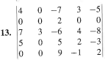

(3.1.2)

Explore the effect of an elementary row operation on the determinant of a matrix. In each case, state the row operation and describe how it affects the determinant.

1. 
2. 
3. 

**What are determinants used for?**

(3.1.3)

Use determinants (calculated by hand) to determine if the matrix is invertible

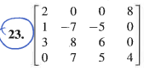

(3.1.4)

Use determinants (calculated by hand) to determine if the vectors are linearly independent

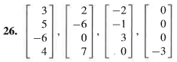

**Simple claims you can prove about determinants**

(3.1.5)

Claim: If *A* and *P* are square matrices and *P* is invertible, then .

(3.1.7 theory question)

Claim: If  is an  matrix such that , then 

**While determinants have fallen out of favor, there still is a bunch of theory that surrounds them**

(3.1.6)

**True or False Instruction:** Assume that matrices are square unless told otherwise. Remember that an answer without a written explanation is only half of an answer.

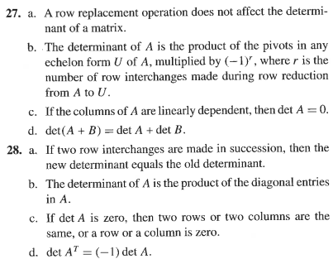

(3.1.1 solution)

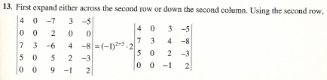

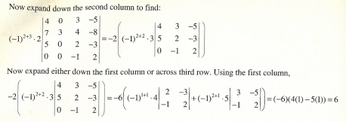

(3.1.2 solution)

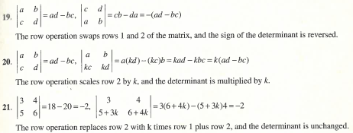

(3.1.3 solution)

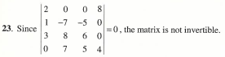

(3.1.4 solution)

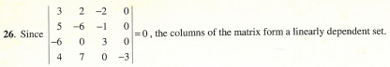

(3.1.5 solution)

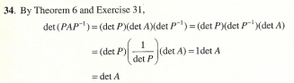

(3.1.6 solution)



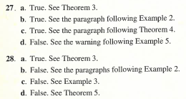

(3.1.7 proof)

