**Math 220  
2.3: Characteristics of Invertible Matrices   
Questions for flipped class**

**Important terms**Invertible  
  
  
  
  
Singular

**Thinking about invertible matrices**

(2.3.1) Can you answer the following questions without a calculator in 8 minutes or less?

Determine which of these matrices are invertible using as few calculations as possible.

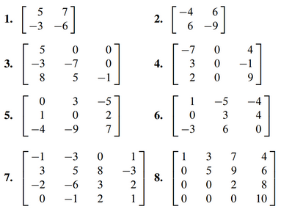

**It’s all about the invertible matrix theorem.**

(2.3.2)



(2.3.3)

An *m* x *n* upper triangular matrix is one whose entries *below* the main diagonal are 0’s. When is a square upper triangular matrix invertible? Justify your answer.

(2.3.4)



(2.3.5)

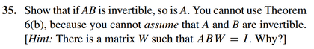

**Have we mentioned the Invertible matrix theorem?**

(2.3.6)

Assume matrices are n x n unless otherwise specified.

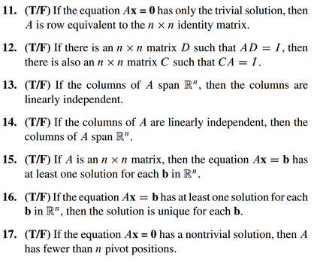

(2.3.7)

The Invertible Matrix Theorem essentially divides the set of all *n* x *n* matrices into two disjoint sets.

|  |  |
| --- | --- |
| **Invertible (*A* has an inverse)** | **Not invertible (*A* does not have an inverse)** |
|  |  |
|  |  |
|  |  |
|  |  |
|  |  |
|  |  |
|  |  |
|  |  |
|  |  |

(2.3.1 solution)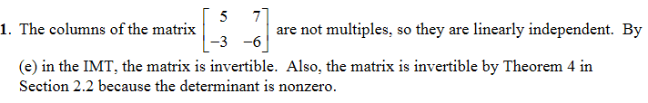



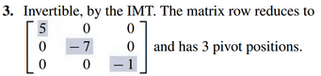

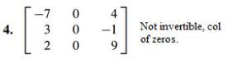

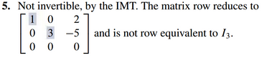

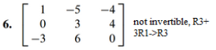

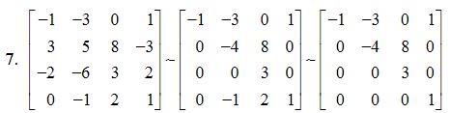

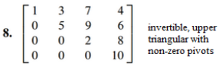

(2.3.2 solution)



(2.3.3 solution)



(2.3.4 solution)

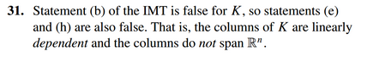

(2.3.5 solution)

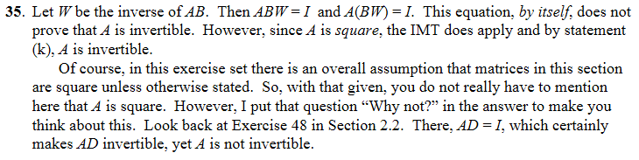

(2.3.6 solution)

