**Math 220  
2.2: The Inverse of a Matrix   
Questions for flipped class**

**Important terms**What is the short cut formula for finding the inverse of a 2x2 matrix?  
  
  
  
  
Does this formula work for matrices with other dimensions?

A matrix that has an inverse is said to be invertible. That’s invertible with a T.

**Crawling …**

**Calculator Instruction**: Use RREF to find the matrix inverse (or use the formula for 2x2 cases).

(2.2.1)

Find the inverse of:

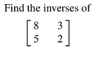

(2.2.2)

Solve the following system using row reduction AND using the inverse found in the previous exercise:

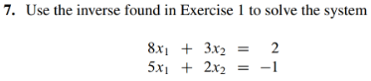

(2.2.3)

Find the inverse of:

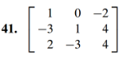

**Walking …**

(2.2.4)



(2.2.5)



(2.2.7 theory question)

Claim: If *A* is an invertible *n* x *n* matrix, then for each in Rn, the equation *A****x*** *=* ***b***has the unique solution 

Proof.

**Running …**

(2.2.6)

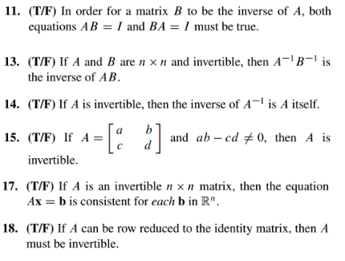

(2.2.1 solution)



(2.2.2 solution)



(2.2.3 solution)

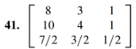

(2.2.4 solution)

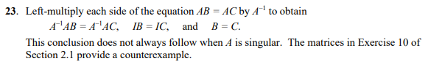

(2.2.5 solution)

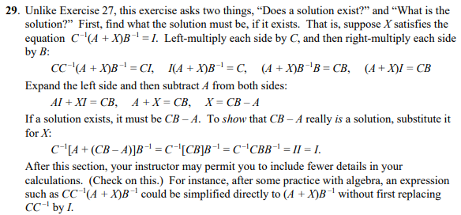

(2.2.6 solution)

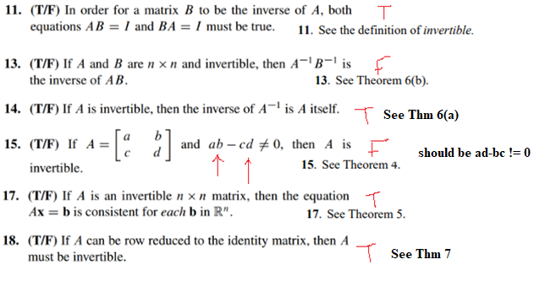

(2.2.7 proof)

