**Math 220  
2.1: Matrix Operations  
Questions for flipped class**

**Key terms**:

Transpose

Commutative property of multiplication

No extra charge: Symmetric matrices

**For Everyone**

(2.1.1) This question is about dimensions and matrix multiplication.

Compute *A*+2*B*, 3*C*-*E*, *CB*, and *EB* by hand. If an expression is undefined, explain why  
  
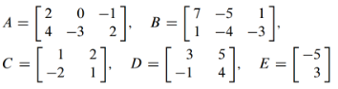

(2.1.3) This question is about the (lack of) commutativity of matrix multiplication.



**How much skills practice do you need?**

(2.1.2) Sometimes matrix multiplication is commutative.

(2.1.4) Think about this question relative to old school factoring … *AB* = 0 but neither factor is zero!

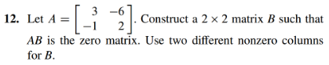

(2.1.5) Notice how the dimensions change …

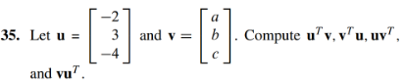

**Thinking about Theory**

(2.1.6)

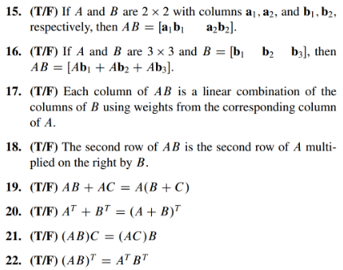

(2.1.1 solution)

* 
* 3C-E is undefined because the dimensions are not the same in C and E
* 
* EB is undefined because the dimensions are mismatched

(2.1.2 solution)



(2.1.3 solution)

*  and  but B and C aren’t equal.

(2.1.4 solution)

* Notice that column 2 is (-2)*(col 1). So let 

(2.1.5 solution)

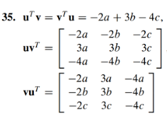

(2.1.6 solution)

