**Math 220  
1.8 Linear Transformations  
Questions for flipped class**

**Key terms**:

Standard basis vectors: , , …

Definition of a Linear Transformation (memorize this!)

Note:

Up to this point in the class, almost every matrix we have worked with is directly connected to a system of equations and augmented matrix. We are mostly doing “equation math” related to solving.

Linear transformations are like functions. Now we do things like evaluate, talk about domain and range (image), whether functions are invertible, and (of course) what the transformations do.

**Thinking about the past**

(1.8.1)

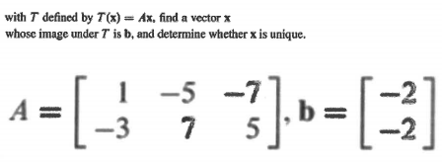

(1.8.2)



**Thinking Graphically**

(1.8.3)

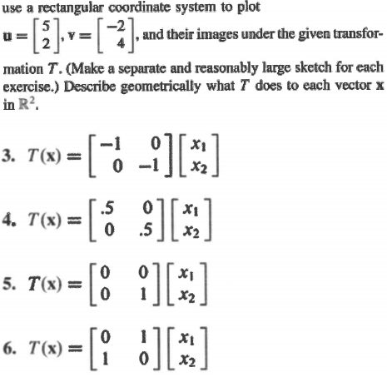

**Thinking Creatively**

(1.8.4)

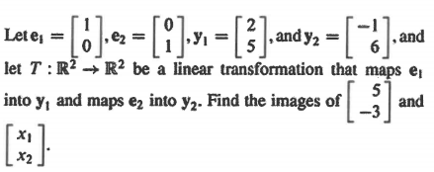

(1.8.6)

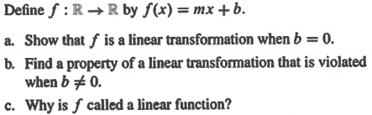

**Thinking Theoretically**

(1.8.5)

(1.8.7 theory question)

How will we begin showing a function is a linear transformation? That is, what are the assumptions/definitions we will make at the outset?

(1.8.1 solution)



(1.8.2 solution)



(1.8.3 solution)

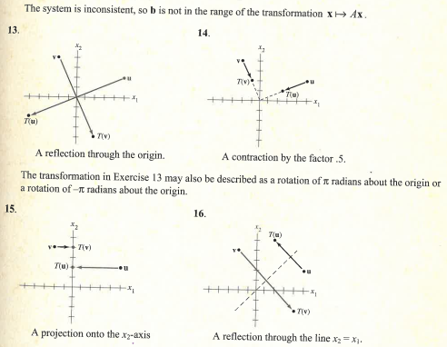

(1.8.4 solution)



(1.8.5 solution)

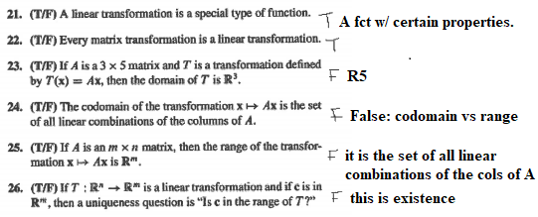

(1.8.6 solution)

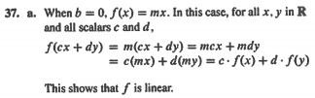

(1.8.7 theory solution)

How will we begin showing a function is a linear transformation? That is, what are the assumptions/definitions we will make at the outset?

Claim: T: X -> Y is a linear transformation.

Let T be as given above and scalar *c* and u,v in X be given.