**Math 220  
1.5: Solution Sets of Linear Systems  
Questions for flipped class**

**Key terms**:

Homogeneous equation

Trivial solution

Non-trivial solution to the homogeneous equation

(1.5.1)

Determine if the system has a non-trivial solution. Try to use as few row operations as possible. Then write the solution set of the system in parametric vector form.

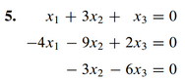

**The Few**

(1.5.2)

Describe all solutions of *A***x** = **0** in parametric vector form, where *A* is row equivalent to the following matrices.

1. Matrix *A*



1. Matrix *A*

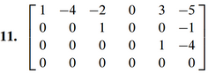

(1.5.3) (connection between Math 163 and 220)



**The Proud**

(1.5.4) (connection between Math 163 and 220)

Find the parametric equation of the line thru **a** and parallel to **b**



(1.5.5) (This question introduces you to what another book called “The Kyle Numbers.”

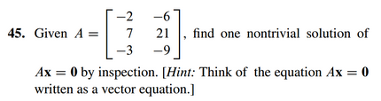

For an explanation of “Kyle Numbers,” see https://abel.math.harvard.edu/~knill/teaching/math21b2015/exhibits/kyle/index.html

**The Marines**

(1.5.6)

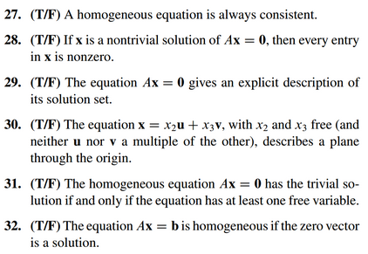

(1.5.7 theory question)

Prove the following claim.

Claim: Suppose  is a solution of , so that . Let  be any solution to the homogeneous equation , and let , show that  is a solution of .

(1.5.1 solution)

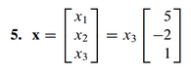

(1.5.2 solution)

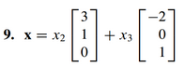

And

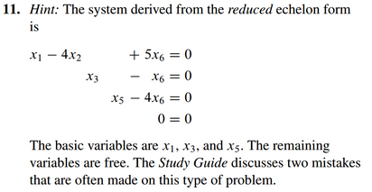

(1.5.3 solution)

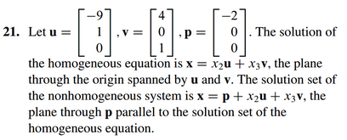

(1.5.4 solution)

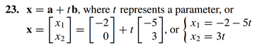

(1.5.5 solution)



(1.5.6 solution)

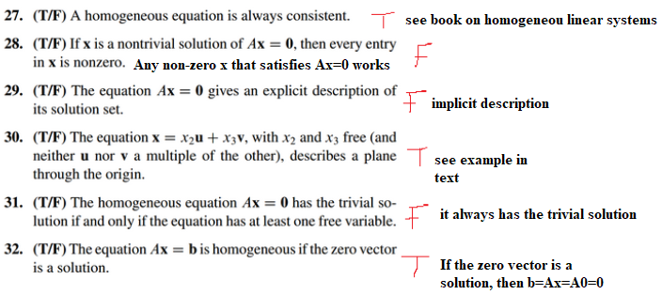

(1.5.7 theory solution)

