**Math 220  
1.1: Systems of Linear Equations  
Questions for flipped class**

**Questions for everyone**

(1.1.1)

Consider the accompanying matrix as the augmented matrix of a linear system. State in words the next two elementary row operations that should be performed in the process of solving the system.

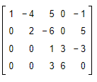

(1.1.2)

The augmented matrix of a linear system has been reduced by row operations to the form shown. Continue the appropriate row operations by hand and describe the solution set of the original system.

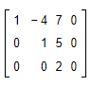

**More practice**

(1.1.3)

The augmented matrix of a linear system has been reduced by row operations to the form shown. Continue the appropriate row operations by hand and describe the solution set of the original system.

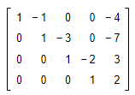

(1.1.4)

Solve the system by hand using the matrix methods.

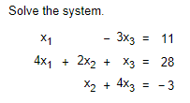

**Round 1 of Theory**

(1.1.5)

Determine the​ value(s) of *h* such that the matrix is the augmented matrix of a consistent linear system.

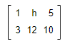

(1.1.7 theory question)

Rewrite the statements as if-then statements. That is, if ________ then _________.

1. Two matrices are row equivalent if they have the same number of rows.
2. An inconsistent system has more than one solution

**Round 2 of Theory**

(1.1.6)

About T/F: Nearly every lesson includes a set of true/false statements. These are key statements from the section that are either quoted directly, restated slightly (but still true), or altered in some way that makes them false in some cases.

Mark each statement as True or False, and justify your answer.

* If true, give the approximate location in the notes/text where a similar statement appears or refer to a definition or theorem.
* If false, give the location of a statement that has been quoted incorrectly, or cite a counter-example (an example that shows the statement is not true in all cases).

Questions of this type will appear on the Assessments

(1.1.1 solution)





(1.1.2 solution)



(1.1.3 solution)



(1.1.4 solution)



(1.1.5 solution)



(1.1.6 solution)

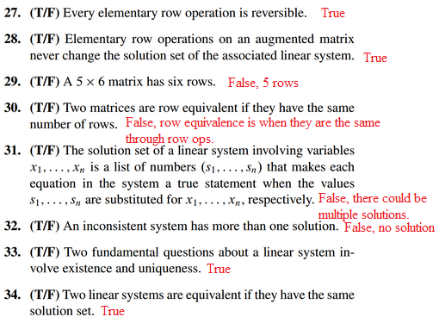

(1.1.7 solution)

Rewrite statements (0.) and (2.) above as if-then statements. That is, if ________ then _________.

1. If two matrices have the same number of rows, then the matrices are row equivalent.

(2.) If a system is inconsistent, then it has more than one solution.