The columns of  are  and . Suppose *T* is a linear transformation from  such that  and .

Find a formula for the image of an arbitrary .

This shows us that knowing  and  can give us  for any . That is, for all we have:

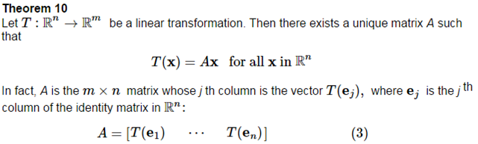

This Matrix *A* is called the _________________________________________________

_____________________________________________________________________.

Find the standard matrix *A* for the contraction transformation  for .

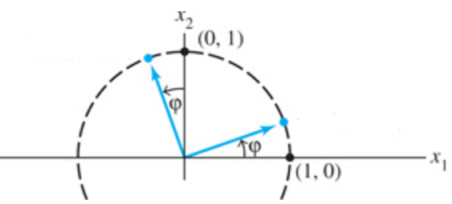Let  be the transformation that rotates each point in  about the origin through the angle , with counterclockwise rotation for a positive angle (see the figure). Find the standard matrix *A* of this transformation.

**Geometric Applications of Linear Transformations**

Observe and discuss in the interactive ebook: *(also, pages 74-76)*

* Reflection
* Contraction & Expansion
* Shear
* Projection

**The Theory of Linear Transformations**

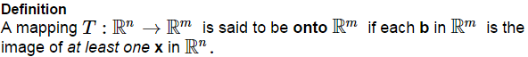

Another way of saying this is that the _________ of *T* is all of the______________

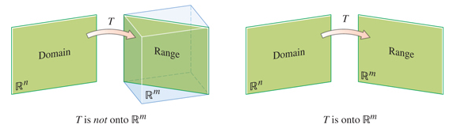

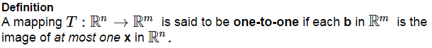

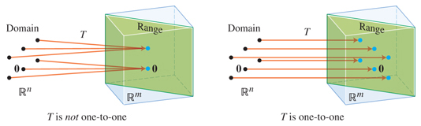

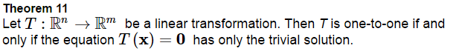

**Proof.**

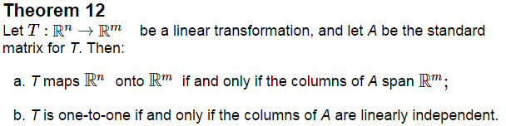

**Proof.**

Let T be the linear transformation whose standard matrix is below (2 cases). Determine whether they are “onto ” and/or a one-to-one mapping.

1.  b) 

|  |  |  |
| --- | --- | --- |
|  | Why? | Why? |
| onto ? |  |  |
| one-to-one? |  |  |