A system of linear equations is called ___________________________ if it can be written as  Such a system always has the ________________ solution ______.

The important question is whether or not there is a ________________________ solution to a homogeneous system.

Since there is always a trivial solution, there is a non-trivial solution if and only if there is at least one __________ ______________________.

Determine whether the following has a non-trivial solution, and if so, describe the solution set.

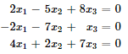

Describe all the solutions of the homogeneous “system”.



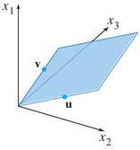

The previous example demonstrates how we can write solutions in Parametric Vector Form.  

**Solutions of Nonhomogeneous Systems**

Describe all solutions of **.**  and 

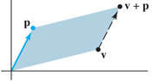

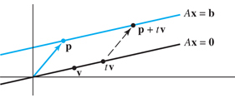To visualize the solution set of  geometrically, we can think of vector addition as a __________________________.

The solution set of  is a line through  ____________________ to the solution set of ____________.

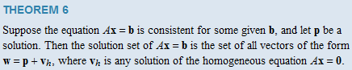

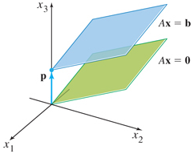

Claim (the first part of Theorem 6): Suppose that  is a solution of , so that . If  is any solution to the homogeneous equation  and  then  is a solution to .

**Process:** Writing a solution set (of a consistent system) in Parametric Vector Form.

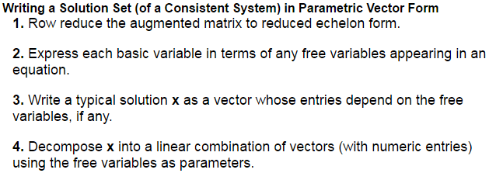

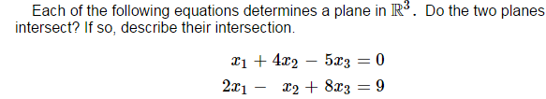



1.6 – Applications (read/review Network Flow as well – pages 53 – 54 )

