Five Star Cleaners
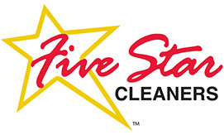 1090 10th Ave. S, Seattle, WA 98111. 800-232-0055

Thursday, December 07, 2017

Tommy Chin
3469 Twin Peaks Ave.
Tukwila, WA 98231

Dear Tommy Chin:

As the manager on duty on the day of Tuesday, December 05, 2017, I am writing this letter to apologize for the inadequate service that you received. Enclosed is a check that reimburses you for the service that you were charged. In addition to the check, there is a $100 certificate for future services here at Five Start Cleaners. As you have been a customer for over a decade, we appreciate your continued business and hope that this letter, check and certificate will express our sincere apologies for the inadequate service that you received last Tuesday.

Sincerely,

Gigi Reynolds, Manager Five Star Cleaners

