Cornucopia Health Food Store

Centerbrook Mall

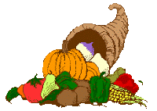

Grand Opening!

9:00 AM on Monday, October 4

First 50 Customers At Register Get Free Bottle Of Vitamin C!

Discount Coupons All Day Long

Free Samples All Day Long

Huge Selection Everyday All Year Long:

* Tofu
* Carob
* Herbal Teas
* Soy Products
* Vitamin Supplements
* Organically Grown Produce