Video Project 43 Excel 2013 Basics 25: Charts
Goal in video: Learn how to create basic charts in Excel.
Topics Covered in Video:
  - Charts often times come from tables of data that have not been summarized (un-summarized data).
  - Charts = Graph = Picture of number data
  - What do Charts do?
    - Visually portray Quantitative data (number data).
    - Give a quick impression of the number data.
    - Create a picture that can communicate more quickly than just the numbers alone.
    - Charts allow you to see patterns or trends that you may not be able to see if you are looking at just the number data.
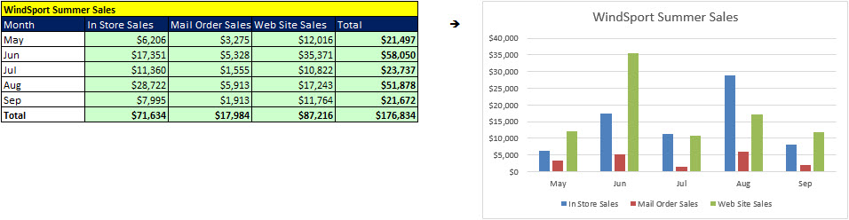
  - Chart elements:
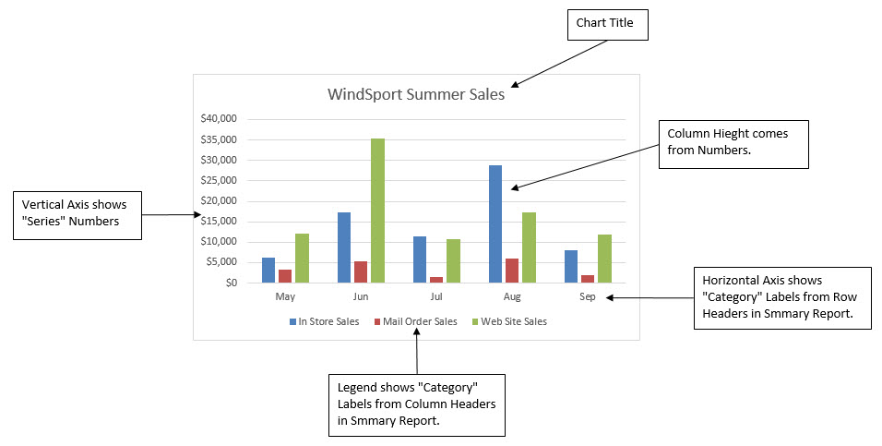
  - Effective charts:
    - Number data AND labels for the number data
    - No “Chart Junk”
      - Chart Junk:
        - Unnecessary Repetition
        - Chart elements that do not contribute to the message
        - Chart elements that make the chart look busy
          - Too many different colors
          - Patterns that are distracting
        - 3-D effects that are not necessary or misleading
  - Types of Charts:
    - Columns:
      - Remember: Columns hold up Greek Architecture
      - Show differences (in numbers) across categories (labels)
      - Great chart for cross tabulated data (from our PivotTable video).
        - If the number of row headers are equal or greater than to the number of column headers, row headers show up on horizontal axis and column headers in legend. If not, they are reversed. (You can switch this with the Switch button in the Chart Tools Design Ribbon Tab).
      - Stacked Columns
        - Same as Column, except legend items will show up in the stacked bar.
    - Bars and Stacked Bars
      - Same as column, except:
        - Horizontal
        - Columns are shown horizontal and are called bars
        - Bars can emphasize the differences between the categories better than a column chart
        - Sometimes Bars show long labels better than Column
    - Pie
      - Parts that make up the whole
      - Don’t included totals in a Pie Chart
    - Line
      - One number on vertical axis, category on horizontal axis
      - Great for show trends over time
    - X-Y Scatter
      - One number on vertical axis, one number on horizontal axis
      - Linear Algebra chart that shows the relationship between two variables
      - Always put X values in Left Most Column
      - Add Regression Line and Equation and R Square:
        - Right-click plotted scatter markers
        - Add Trendline
        - Select Linear
        - Check check box for Show Equation
        - Check check box for R Square

    - Sparklines
      - Sparklines are Cell Charts
      - Create Sparklines:
        - Insert Ribbon Tab
        - Sparkline Group
    - Recommended Charts
      - Click in non-summarized data set and see if it has an option you like.
  - Charts can be found in Insert Ribbon Tab
  - Format Chart Elements with:
    - Chart Elements Icon that shows up to the Right of the Chart
    - Chart Styles Icon that shows up to the Right of the Chart
    - Chart Filter Icon that shows up to the Right of the Chart (Be sure to click the Apply button)
    - Format Chart Element with Task Pane (keyboard: Ctrl + 1)
  - Link Labels to Cells:
    - Click on Chart Title
    - Click in Formula Bar
    - Type equal sign
    - Click on cell with label
    - Hit Enter
  - BIG KEY: If the chart does not come out right:
    - Chart Tools Design Ribbon Tab
    - Data Group, Select Data button
      - Series = Number
      - Category = Labels
- New Keyboard Shortcut:
  - Format Chart Element with Task Pane: Ctrl + 1
  - Create Default Chart on Current Sheet; Alt + F1
  - Create Default Chart on new sheet: F11

