Review for Test 1
Math 230: Differential Equations
Format
- The exam will contain 8 problems (plus or minus 3) and will last 50 minutes.
- It is a paper and pencil exam.
- You will need to show your work.
- You may use a graphing calculator. However, you may not use a symbolic calculator such as the TI-89. If you do not bring an acceptable calculator, you may have to do without.
- You must be able to answer warm up questions and paraphrase mathematical quotes such as those found at:
http://www-groups.dcs.st-andrews.ac.uk/~history/Quotations/Erdos.html

Basic Content.
- You are responsible for sections 1.1-3 and 2.1-5.
- In addition to the material covered in the class, you are responsible for all of the basic facts you have learned since kindergarten. These include the facts that Barack Obama is the President of the United States of America, , and that 1/0 is undefined.
In Studying . . .
- You should be able to recreate every derivation/proof done in class (which isn’t very many).
- You need to know the vocabulary.
- You must recognize the various forms and know the appropriate methods for solving each DE.
- You should be able to solve every example done in class.
- You should be able to solve every homework question.
Ideas that may help with test prep …
- Review the most recent material first.
- Consider recopying your notes.
- Summarize your notes. Make note cards for important formulas and definitions. Set them aside once the definitions are known.
- Rework examples from class and homework questions (in this order).
- Look to the review exercises for additional practice.
- Practice like you will play – do you know the material without your notes when the clock is running?
- Study with a friend to have more fun.
- Look to online resources such as YouTube and the Khan Academy to fill in holes.
- Show up at least five minutes early for the exam.

A Summary of the Topics (not necessarily exhaustive)
- 1.1: Definitions and Terminology
  - Recognize the type and order of DE
  - Verify solutions
  - Determine particular solutions (IVP)
- 1.2: Initial Value Problems (IVP)
  - Determine the interval of definition of a solution
  - Determine the interval of definition of a unique solution
    - Existence and uniqueness …
- 1.3: Differential Equations (DE) as Models
  - Use DE to construct models
- 2.1: Solution Curves Without a Solution
  - Read and construct direction fields
  - Read and construct phase portraits
  - Classify critical points
  - Sketch solutions for autonomous DE
- 2.2: Separable Equations
  - Recognize and solve separable equations
- 2.3: Linear Equations
  - Recognize and solve linear DE
  - Recognize transient terms
  - Be aware of singular points
  - Note: I do not plan to test on functions defined by integrals.
- 2.4: Exact Equations
  - Recognize and solve an exact DE
  - Important: Make sure to test to verify a DE is exact
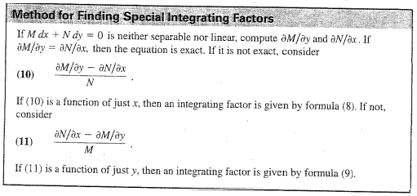
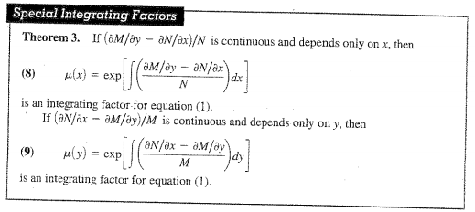
- 2.5: Solutions by Substitution
  - Recognize when to apply the three substitutions
    - Homogeneous DE
    - Bernoulli DE
    - DE that can be reduced to separable
- Notes: At least some of the DE’s you must solve will be labeled by type.

College Search Tools
College Board: https://bigfuture.collegeboard.org/college-search
One of the benefits of this site is that you can easily come up with a list of good-fit colleges using filters like location (search by region, specific state, or all of US), majors offered, and setting (rural vs urban).
Cappex: http://www.cappex.com/
This site requires you to create an account and fill out a profile with details like GPA, test scores, and major in order to match you with colleges. One of the highlights of cappex is that it enables you to do side-by-side comparisons of colleges that interest you. Cappex also has a scholarship section, so you can use the site to both research colleges and scholarships.
No Loan Schools: http://www.finaid.org/questions/noloansforlowincome.phtml
This link provides information about no-loan schools. If you scroll down in the article you will come across a long table with information about colleges that have eliminated or greatly reduced the percentage of financial need met through student loans.
Scholarship Search Tools:
Cappex (see college search tools)
Fastweb: http://www.fastweb.com/
Similar to cappex in that you must create an account and fill out a profile to be matched with scholarships. If you have an email account you use for spam, I recommend using that email address as fastweb does generate a number of emails.
Washboard: http://washboard.org/login.aspx
You mentioned that you are already familiar with this site. But be sure to check back on a regular basis for new scholarships. Winter is the period when many scholarships are posted and have deadlines.
Strategies for using Google
In addition to using scholarship search tools, consider using google and searching for specific criteria such as “scholarships for women in science” or “scholarships for latina women.”
UW Scholarships: http://www.washington.edu/students/osfa/ugaid/scholarship.html
In addition to all of the scholarships offered by outside organizations, UW offers a number of scholarships, some of which are specifically reserved for transfer students.
As you compile your list of target colleges and scholarships please feel free to reach out to me with any questions. Another great resource on campus is the Transfer Center located in building 6 (http://transfercenter.highline.edu/). The director, Siew Lai, is very knowledgeable and always willing to help students.
ASSIGNMENT: PERSONAL STATEMENT
The personal statement is your big chance. This is your OPPORTUNITY to distinguish yourself, to make your personal life experience really count, to document how you have triumphed over adversity just to get to the same spot that more affluent students have arrived at being “carried” by their families. Now is the time to BE UNIQUE.
Most colleges and universities cannot accept everyone who applies. Other applicants will have a GPA as high as yours, or perhaps even higher. Others will have participated in activities and community service, perhaps even more than you did if you’re one of the community college student who had to work 20-40 hours a week just to survive. But a personal statement is your opportunity to extend the school’s knowledge of you beyond your transcript and your resume. This is your chance to manage their impression of you.
Almost every school will have a specific question that is their topic for their particular personal statement. It is CRUCIAL that you in some way mention that question in your opening paragraph or two, so they know you are writing specifically for them and not just generally for any school (unless you are writing the Common Application) So, YES, answer the question.
But you must also know how the “game” is played. While many schools will NOT tell you this, they ALL EXPECT A PARTCULAR TYPE OF ANSWER. While they will mention answering their question, and they may mention that they want this essay to be a chance to get to know you better, ALL SCHOOLS ARE LOOKING FOR SPECIFIC EVIDENCE.
They want you to weave into your essay information about
- Your academic history
- Your academic and career goals
- Any hardships or challenges you’ve faced
- Your experience with different cultures
- Why you want to go to that institution
- Why the institution should want to accept you

You need to write clearly and engagingly about each of these topics (not necessarily in the order above), using specific FACTS and DATA to support each of your statements. As you will hear me say later, “You need to SHOW AND NOT TELL” them what to think about you.
The good news is that if you do that well, you can address their question in your first paragraph, the reasons for going to their institution and what you can bring to it in your concluding paragraph, and use the clear and engaging middle sections about your academic history, academic and career goals, challenges overcome, and experience with diversity over and over again in different essays for different schools.
Keep in mind that many colleges are relying on personal statements and teacher recommendations more heavily in their admissions decisions than on transcripts.
Let go of perfect for the first draft. Get your story down on paper. The sooner you begin writing, the more time you’ll have to revise.

