**Review for Test 3**

**Math 098: Intermediate Algebra for Calculus**

**Format**

* The exam will be 6-10 pages in length, 25-40 questions and will last 110 minutes.
* It is a paper and pencil exam.
* You will need to show your work.
* You may use a graphing calculator. However, you may not use a symbolic calculator such as the TI-89.
* You must be able to answer warm up questions and paraphrase mathematical quotes:  
    
  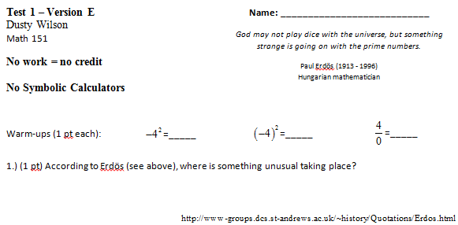

What will my exam look like?

**Basic Content.**

* You are responsible for all sections covered in this course: 2.1, 5.1-7, 6.1-4, 7.1-6, and 7.8, 8.1-3, 8.6&7, and 8.9.
* In addition to the material covered in the class, you are responsible for all of the basic facts you have learned since kindergarten. These include the facts that Barack Obama is the President of the United States of America, , , and that 1/0 is undefined.

**In Studying . . .**

* You should be able to work through every question from a workalong.
* Study materials in MyLabsPlus.
  + There is a Chapter 8 review quiz (infinite takes).
  + I have also reopened all the practice tests if you would like to work thru these to review previous chapters (and increase your grades on those assignments).
* Make sure to work thru the old exams (these are posted on my website).

**Ideas that may help with test prep …**

* Review the most recent material first (sections 8.9, 8.7, 7.8, 7.6, 6.4, 5.4-5.6, 2.1).
* Consider recopying your notes.
* Summarize your notes. Make note cards for important formulas and definitions. Set them aside once the definitions are known.
* Rework quiz questions, examples from class, and homework questions (in this order).
* Practice like you will play – do you know the material without your notes when the clock is running?
* Study with a friend to have more fun.
* Look to online resources such as the class videos and the Khan Academy to fill in holes.
* Show up at least five minutes early for the exam.
* Get a good night sleep … eat a healthy breakfast … and do something slightly active before the test to get your blood and brain moving.

**Section 2.1: Functions**

* The definition of a function
* Domain and range (including how to find them given a graph)
* Function notation
* Evaluating functions given graphs and equations
* Recognizing functions given a graph (the vertical line test)
* Using the calculator to graph functions, find their domain and range, find *x*-intercepts, intersections, and max/mins

**Chapter 5: Polynomials, Factoring, and Solving Equations**

* *Introduction to Polynomials*
  + Definition of a polynomial
  + The vocabulary of polynomials
  + Evaluating polynomial functions
  + Adding and subtracting polynomials
* *Multiplying polynomials*
* *Factoring*
  + Factoring out the GCF
  + Factoring by grouping (usually if there are four terms)
  + Factoring quadratics of the form 
    - What if *c* > 0?
    - What if *b* > 0?
    - Check!!!
  + Factoring quadratics of the form 
    - What if *c* > 0?
    - What if *b* > 0?
    - Check!!!
  + Factoring the difference of squares, perfect squares, and the sum/difference of cubes.
* *Solving Equations*
  + Put equations in standard form
  + If the polynomial can be factored, then the zeros of each factor are the solution to the equation.
  + If the polynomial can’t be factored, graph it and look for its zeros.

**Chapter 6: Rational Expressions, Equations, and Functions**

* Multiply straight across
* Divide by inverting and multiplying
* To add/subtract, make sure you have a common denominator
* To simplify complex rational expressions, multiply by a special one formed from the LCD of the full expression.
* Expressions are undefined when the denominator is zero.
* To solve rational equations, multiply both sides of the equation by the LCD. Make sure to check for extraneous solutions.

**Chapter 7: Exponents and Radical Functions**

* Understand basic roots including how to evaluate them by hand and using a calculator.
* Find the domain and range of a radical function (the latter part using the graph).
* Understand the relationship between rational exponents and roots.
* Understand how to add, subtract, multiply, and divide radical expressions.
* Understand how to rationalize the denominator (this includes the conjugate)
* Solve radical equations making sure to check for extraneous solutions.
* Understand complex numbers and how to perform basic arithmetic operations with them.

**Chapter 8: Quadratics**

* Methods to solve quadratic equations. Graphically, solving quadratic equations is synonymous to finding the zeros or *x*-intercepts of the function.
  + Factoring
  + The principle of square roots
  + Completing the square
  + The quadratic formula
    - The discriminant
* The vertex
  + The vertex of a quadratic is a point
  + If the the graph of a quadratic equation is given by  or , then the vertex is  or 
  + The axis of symmetry is  or 
* Domain and range
  + The domain of the quadratic is all real numbers: 
  + The range is either  or  depending upon the concavity.

**Review questions** (tough ones from online): 5.7.37, 6.3.45, 6.4.45, 7.5.73, 7.6.49 and 51, 8.1.63, 8.2.19 and 31, 8.4.49 and 51.

**Review questions** (from chapter 6):

|  |  |
| --- | --- |
| Solve | Solve |
|  |  |
|  |  |
|  |  |
|  |  |
|  |  |
|  |  |
|  |  |
|  |  |
|  |  |
| Solve |  |
| Solve |  |
| Solve |  |