Review for Test 1
Math 111: College Algebra

Format
- The exam will be 4-5 pages in length, 8-12 questions and will last 50 minutes.
- It is a paper and pencil exam.
- You will need to show your work.
- You may use a graphing calculator. However, you may not use a symbolic calculator such as the TI-89 (without permission).
- You must be able to answer warm up questions and paraphrase mathematical quotes such as those found at:
http://www-groups.dcs.st-andrews.ac.uk/~history/Quotations/Erdos.html
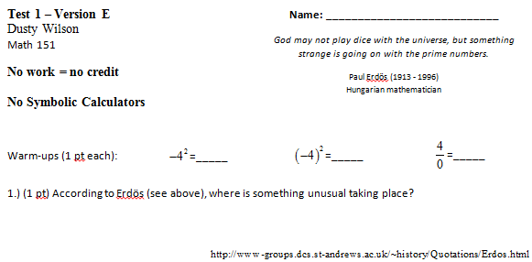
What will my exam look like?
Basic Content.
- You are responsible for sections 1.1 – 1.4, 1.6, 2.1 – 2.5.
- In addition to the material covered in the class, you are responsible for all of the basic facts you have learned since kindergarten. These include the facts that Barack Obama is the President of the United States of America, , and that 1/0 is undefined.

In Studying . . .
- You should be able to work through every question from a handout.
- You should be comfortable with all the quiz questions you have seen.
- You should be able to solve every example done in class.
- You should be able to solve every homework question.

Ideas that may help with test prep …
- Review the most recent material first.
- Consider recopying your notes.
- Summarize your notes. Make note cards for important formulas and definitions. Set them aside once the definitions are known.
- Rework quiz questions, examples from class, and homework questions (in this order).
- Look to the review exercises for additional practice.
- Practice like you will play – do you know the material without your notes when the clock is running.
- Study with a friend to have more fun.
- Look to online resources such as YouTube and the Khan Academy to fill in holes.
- Show up at least five minutes early for the exam.
- Don’t forget our handouts on revenue, cost, profit, arbitrary function graphs, piecewise examples, and data analysis.

Chapter 1: Areas of Focus
- You should be able to read graphs given the input or the output value. Remember that given the graph of a function, one input can only have one output. However, one output could have been mapped from more than one input.
- Remember the difference between an undefined expression and an equation with no solution.
- You should be able to interpret any results from graphs using complete English sentences.
- You must be able to solve .
- You should be able to evaluate functions and do basic function operations such as addition and subtraction.
- You must be able to find the equation of a line given two points, or the slope and one point, or the slope and y-intercept.
- You should be able to find and interpret the slope in context. This includes interpreting marginal revenue, cost, and profit.
- You should be able to find and interpret the intercepts using complete sentences.
- You should be able to find a reasonable domain and range for an applied function.
- You should be able to solve and interpret questions relating to break-even analysis.
- You should be able to solve and interpret questions relating to market equilibrium including accounting for taxes to the supplier passed on to the consumer.

Chapter 2: Areas of Focus
- Methods for solving quadratic equations
  - Factoring
  - The quadratic formula
  - Solving by graphing
- Graphs of quadratic equations
  - The meaning of a, b, and c. Remember that b is the slope of the parabola at the y-intercept.
  - The axis of symmetry
  - The vertex of a parabola.
- Applications of quadratic equations
  - Supply and Demand
    - Finding market equilibrium
    - Accounting for taxes.
  - Profit, Revenue, and Cost
    - Break-even points
    - Optimization problems (find the vertex).
    - Determining what the function is given information. (See 2.3 #31 and 32 in the text).
    - Determine a realistic domain for a given function
  - Interpret your results in the context of the problem using complete English sentences.
- Piecewise defined functions
  - Know how to evaluate piecewise functions.
  - Know how to graph piecewise functions.
  - Know how to set up piecewise functions in applications.
- Data Analysis
  - Know how to find models and eyeball their validity.
  - Know how to evaluate and interpret models in context.

