**Review for Test 2**

**Math 098: Intermediate Algebra for Calculus**

**Format**

* The exam will be 4-6 pages in length, 15-25 questions and will last 63 minutes.
* It is a paper and pencil exam.
* You will need to show your work.
* You may use a graphing calculator. However, you may not use a symbolic calculator such as the TI-89.
* You must be able to answer warm up questions and paraphrase mathematical quotes:  
    
  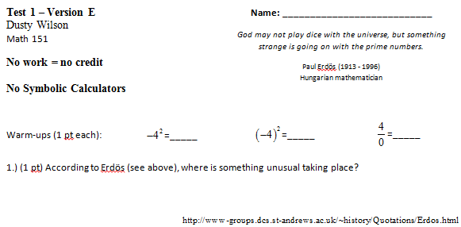

What will my exam look like?

**Basic Content.**

* You are responsible for sections 6.1-4, 7.1-6, and 7.8.
* In addition to the material covered in the class, you are responsible for all of the basic facts you have learned since kindergarten. These include the facts that Barack Obama is the President of the United States of America, , and that 1/0 is undefined.

**In Studying . . .**

* You should be able to work through every question from a workalong.
* You should be comfortable with all the quiz questions you have seen.
* You should be able to solve every homework question.

**Ideas that may help with test prep …**

* Review the most recent material first.
* Consider recopying your notes.
* Summarize your notes. Make note cards for important formulas and definitions. Set them aside once the definitions are known.
* Rework quiz questions, examples from class, and homework questions (in this order).
* Look to the review exercises for additional practice (in the textbook).
* Practice like you will play – do you know the material without your notes when the clock is running.
* Study with a friend to have more fun.
* Look to online resources such as the class videos, YouTube, and the Khan Academy to fill in holes.
* Show up at least five minutes early for the exam.
* Get a good night sleep … eat a healthy breakfast … and do something slightly active before the test to get your blood and brain moving.

**Chapter 6: Rational Expressions, Equations, and Functions**

* Multiply straight across
* Divide by inverting and multiplying
* To add/subtract, make sure you have a common denominator
* To simplify complex rational expressions, multiply by a special one formed from the LCD of the full expression.
* Expressions are undefined when the denominator is zero.
* To solve rational equations, multiply both sides of the equation by the LCD. Make sure to check for extraneous solutions.

**Chapter 7: Exponents and Radical Functions**

* Understand basic roots including how to evaluate them by hand and using a calculator.
* Find the domain and range of a radical function (the latter part using the graph).
* Understand the relationship between rational exponents and roots.
* Understand how to add, subtract, multiply, and divide radical expressions.
* Understand how to rationalize the denominator (this includes the conjugate)
* Solve radical equations making sure to check for extraneous solutions.
* Understand complex numbers and how to perform basic arithmetic operations with them.

**Review questions** (from the Practice Test):

|  |  |
| --- | --- |
| Consider . Find all values of *a* for which . | Simplify |
|  |  |
| Simplify |  |
|  |  |
| Determine the domain of . Use the graph to find the range. | Solve |
|  |  |
| Simplify |  |
|  |  |
|  | Rationalize the denominator of the expression |
|  |  |
| If , evaluate , , and |  |