**Review for Test 1**

**Math 098: Intermediate Algebra for Calculus**

**Format**

* The exam will be 4-6 pages in length, 15-20 questions and will last 63 minutes.
* It is a paper and pencil exam.
* You will need to show your work.
* You may use a graphing calculator. However, you may not use a symbolic calculator such as the TI-89.
* You must be able to answer warm up questions and paraphrase mathematical quotes:  
    
  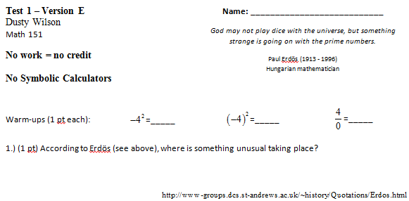

What will my exam look like?

**Basic Content.**

* You are responsible for sections 2.1, 5.1-7.
* In addition to the material covered in the class, you are responsible for all of the basic facts you have learned since kindergarten. These include the facts that Barack Obama is the President of the United States of America, , and that 1/0 is undefined.

**In Studying . . .**

* You should be able to work through every question from a workalong.
* You should be comfortable with all the quiz questions you have seen.
* You should be able to solve every example done in class.
* You should be able to solve every homework question.

**Ideas that may help with test prep …**

* Review the most recent material first.
* Consider recopying your notes.
* Summarize your notes. Make note cards for important formulas and definitions. Set them aside once the definitions are known.
* Rework quiz questions, examples from class, and homework questions (in this order).
* Look to the review exercises for additional practice (in the textbook).
* Practice like you will play – do you know the material without your notes when the clock is running.
* Study with a friend to have more fun.
* Look to online resources such as the class videos, YouTube, and the Khan Academy to fill in holes.
* Show up at least five minutes early for the exam.
* Get a good night sleep … eat a healthy breakfast … and do something slightly active before the test to get your blood and brain moving.

**Section 2.1: Functions**

* The definition of a function
* Domain and range (including how to find them given a graph)
* Function notation
* Evaluating functions given graphs and equations
* Recognizing functions given a graph (the vertical line test)
* Using the calculator to graph functions, find their domain and range, find *x*-intercepts, intersections, and max/mins

**Chapter 5: Polynomials, Factoring, and Solving Equations**

* *Introduction to Polynomials*
  + Definition of a polynomial
  + The vocabulary of polynomials
  + Evaluating polynomial functions
  + Adding and subtracting polynomials
* *Multiplying polynomials*
* *Factoring*
  + Factoring out the GCF
  + Factoring by grouping (usually if there are four terms)
  + Factoring quadratics of the form 
    - What if *c* > 0?
    - What if *b* > 0?
    - Check!!!
  + Factoring quadratics of the form 
    - What if *c* > 0?
    - What if *b* > 0?
    - Check!!!
  + Factoring the difference of squares, perfect squares, and the sum/difference of cubes.
* *Solving Equations*
  + Put equations in standard form
  + If the polynomial can be factored, then the zeros of each factor are the solution to the equation.
  + If the polynomial can’t be factored, graph it and look for its zeros.

**Review questions** (from the Practice Test):

|  |  |
| --- | --- |
| Does the correspondence on a sports team between a player’s name and the number on their jersey represent a function? | Multiply |
|  |  |
| If , find |  |
|  |  |
| Factor | Factor |
|  |  |
| Factor | Solve |
|  |  |
| Factor | Factor |
|  |  |
| Factor |  |