|  |  |
| --- | --- |
| **Polynomial and Rational Inequalities (8.9)** | **Math 098** |

Graphing quadratic functions requires a strong understanding of the “toolkit” function 

|  |  |
| --- | --- |
| Table | Graph |

With that toolkit knowledge, we can graph the transformed “toolkit” quadratic 

Let’s explore each of the parameters: *a, h,* and *k.*

* 
  + If , the quadratic is ________________ or, more precisely, ________________
  + If , the quadratic is ________________ or, more precisely, ________________
* 
  + Shift the quadratic ________________ or ________________ in the ________________   
      
    ________________ of the sign you see.
* 
  + Shift the quadratic ________________ or ________________ in the ________________   
      
    ________________ as the sign you see.

Note: A more rigorous development of these concepts (including the reasons why they work) can be found in section 8.6 of the text.Graph accurately

|  |  |
| --- | --- |
|  |  |
|  |  |

|  |  |
| --- | --- |
|  |  |
|  |  |

Graph  by completing the square

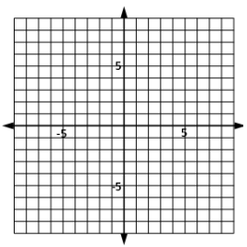

Graph  by completing the square



Graph  by completing the square



Find the Formula: Find the vertex of the general quadratic  by completing the square.

Method: The vertex of a parabola

1. The vertex of the parabola given by  is .
2. The longer version of the formula is: 
3. The *x*-coordinate of the vertex is . The equation of the axis of symmetry is . The second coordinate of the vertex is most commonly found by computing .

Find the vertex of . Check with your graphing calculator.

Consider . Find the vertex, all intercepts, the min/max value, and the range.

Consider . Find the vertex, all intercepts, the min/max value, and the range.

Summary: The graph of a quadratic equation given by  or 

1. The graph is a parabola
2. The vertex is  or 
3. The axis of symmetry is  or 
4. The *y*-intercept of the graph is 
5. The *x*-intercepts can be found by solving 
   1. If , there are two real *x*-intercepts
   2. If , there is one *x*-intercept
   3. If , there are no real *x*-intercepts (although there are two complex zeros)
6. The domain of the function is 
7. If :
   1. The graph opens upward
   2. The function has a minimum value of *k* at 
   3. The range of the function is 
8. If :
   1. The graph opens downward
   2. The function has a maximum value of *k* at 
   3. The range of the function is 