|  |  |
| --- | --- |
| Group Quiz 1Dusty Wilson Math 111 – Spring 2012 No work = no credit | **Name**: ________________________________  ________________________________  ________________________________ |

Consider the heating schedule for building 17 the temperature is a function of time.  
  
Graph this function if:

* At midnight (*t* = 0), the building temperature is 50F.
* This temperature is maintained until 4am.
* The temperature then warms up steadily so that by 8am the temperature is 70F.
* The 70F temperature is maintained until 4pm.
* The building is then gradually cools to 50F by 11pm.
* This temperature is maintained throughout the night.  
    
  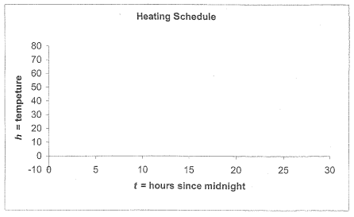

Use the (proper) graph above to answer the following:

1. If we consider  the temperature as a function of time, interpret .
2. What happened in ? Interpret in the context of the question.
3. What happened in ? Interpret in the context of the question.
4. Interpret  in the context of the problem.

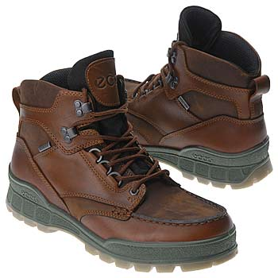 The following problem relates to Ecco boots.   
  
Ecco models their supply by the model: .

1. What do *p* and *q* represent?
2. Find and interpret the *p*-intercept.
3. Find and interpret the slope of the supply model.

Ecco boots can sell 10 pairs of boots if the price is $250/pair and 30 pairs if the price is $170.

1. Construct a demand model for boots.
2. Find and interpret the market equilibrium.