Modeling the spread of a disease in a population
http://en.wikipedia.org/wiki/Compartmental_models_in_epidemiology

The SIR model
Standard convention labels these three compartments S (for susceptible), I (for infectious) and R (for recovered). Therefore, this model is called the SIR model.
This is a good, simple, model for many infectious diseases including measles, mumps and rubella.
The letters also represent the number of people in each compartment at a particular time. To indicate that the numbers might vary over time (even if the total population size remains constant), we make the precise numbers a function of t (time): S(t), I(t) and R(t). For a specific disease in a specific population, these functions may be worked out in order to predict possible outbreaks and bring them under control.

The SIR model is dynamic in three senses
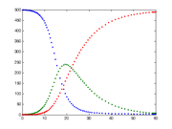
As implied by the variable function of t, the model is dynamic in that the numbers in each compartment may fluctuate over time. The importance of this dynamic aspect is most obvious in an endemic disease with a short infectious period, such as measles in the UK prior to the introduction of a vaccine in 1968. Such diseases tend to occur in cycles of outbreaks due to the variation in number of susceptibles (S(t)) over time. During an epidemic, the number of susceptible individuals falls rapidly as more of them are infected and thus enter the infectious and recovered compartments. The disease cannot break out again until the number of susceptibles has built back up as a result of babies being born into the susceptible compartment.
The epidemic stops when the number of susceptibles drops. Blue=Susceptible, Green=Infected, and Red=Recovered
The SIR is also dynamic in the sense that individuals are born susceptible, then may acquire the infection (move into the infectious compartment) and finally recover (move into the recovered compartment). Thus each member of the population typically progresses from susceptible to infectious to recovered. This can be shown as a flow diagram in which the boxes represent the different compartments and the arrows the transition between compartments.
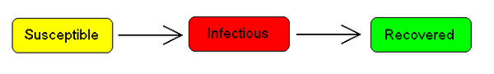

Transition rates
For the full specification of the model, the arrows should be labeled with the transition rates between compartments.
Between S and I, the transition rate is β I, where β is the contact rate, which -roughly speaking - takes into the account the probability of getting the disease in a contact between a susceptible and an infectious subject.
Between I and R, the transition rate is ν (simply the rate of recovery). If the duration of the infection is denoted D, then ν = 1/D, since an individual experiences one recovery in D units of time.
It is important to stress that here we assume that the permanence of each single subject in the epidemic states is a random variable with exponential distribution. More complex and realistic distributions (such as Erlang distributions) can be equally used with few modifications.

Bio-Mathematical Deterministic Treatment of the SIR model

The SIR model without vital dynamics
A single epidemic outbreak is usually far more rapid than the vital dynamics of a population, thus, if the aim is to study the immediate consequences of a single epidemic, one may neglect the birth-death processes. In this case the SIR system described above can be expressed by the following set of differential equations:
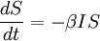
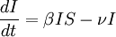
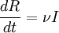
This model was for the first time proposed by O. Kermack and Anderson Gray McKendrick, who had worked with the Nobel Laureate and father of Mathematical Epidemiology Ronald Ross.
This system is non-linear, and so does not admit a generic analytic solution. Nevertheless, significant results can be derived analytically.
Firstly note that from:
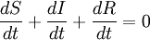
it follows that:
S(t) + I(t) + R(t) = Constant = N
expressing in mathematical terms the constancy of population N. Note that the above relationship implies that one can study the equation for only two of the three variables.
Secondly, we note that the dynamics of the infectious classes depends on the following ratio:
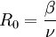
the so-called basic reproduction number (also called basic reproduction ratio). Then by dividing the first differential equation by the third, separating the variables and integrating we get
(where S(0) and R(0) are the initial numbers of, respectively, susceptible and removed subjects). Thus, in the limit , the proportion of recovered individuals obeys the transcendental equation
Consideration of this equation shows that generically, at the end of an epidemic, not all individuals have recovered, so some must remain susceptible. This means that the end of an epidemic is caused by the decline in the number of infected individuals rather than an absolute lack of susceptible subjects. The role of the basic reproduction number is extremely important. In fact, upon rewriting the equation for infectious individuals as follows:
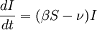
it is clear that if
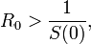
then:
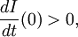
i.e. there will be a proper epidemic outbreak with an increase of the number of the infectious (which can reach a considerable fraction of the population). As a consequence, it is clear that the ratio is extremely important.

