|  |  |
| --- | --- |
| Test 2Dusty Wilson Math 148 No work = no credit | **Name**: _____________________________________________  *Seeing there is nothing that is so troublesome to mathematical practice, nor that doth more molest and hinder calculators, than the multiplications, divisions, square and cubical extractions of great numbers ... I began therefore to consider in my mind by what certain and ready art I might remove those hindrances.*  John Napier (1550 - 1617)  Scottish mathematician |

|  |  |  |  |
| --- | --- | --- | --- |
| Warm-ups (1 pt each): | =_____ | =_____ | =_____ |

(1 pt) The quote by John Napier (above) gives his reasoning behind the invention of the logarithm. In your own words, why did Napier invent the logarithm?

Formulas upon request (note that the pound symbol “#” refers to the word “number”):



(4 pts) Evaluate using limit rules: 

____________________________________________________

(4 pts) Find the derivative of  (simplification is optional)

____________________________________________________

(6 pts) Use the sign diagrams as well as the knowledge that *f* has a vertical asymptote to clearly and carefully sketch a graph of *f*.

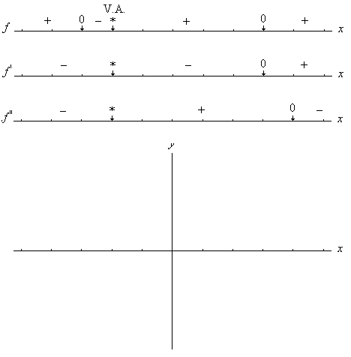

(4 pts) Find the derivative of  (simplification is optional)

____________________________________________________

(10 pts) Use calculus to clearly and carefully sketch a graph of . Find and label all *x*-intercepts, extrema, and points of inflection. Find the absolute minimum of *f* on the interval . You may check with your calculator, but all work must be shown.

1. (8 points) Curve sketching (show work)

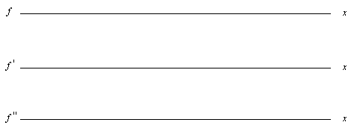

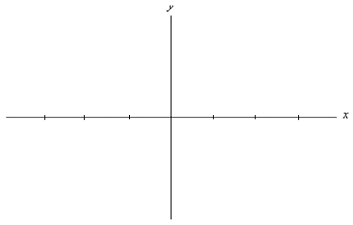

1. (2 points) Use calculus to find the absolute minimum of *f* on the interval  (show work)

(5 pts) Integrate 

____________________________________________________

(5 pts) Integrate 

____________________________________________________

(8 pts)Complete two of the following three questions. Cross out the problem you do not want graded. I retain the right to grade any two problems if you do not select for yourself.

a.) Find the elasticity of the demand function  at . How will a price increase affect total revenue?

b.) The demand and supply functions for a stainless steel refrigerator are

D:  and S:  respectively. Find the tax that would maximize the total tax revenue from this market.

c.) From a tract of land, a developer plans to fence a rectangular region and then divide it into two identical rectangular lots by putting a fence down the middle. Suppose that the fence for the outside boundary costs $5/foot and the fence for the middle costs $2/foot. If each lot contains 13,500 square feet, find the dimensions of each lot that yield the minimum cost for the fence.