|  |  |
| --- | --- |
| Test 2Dusty Wilson Math 148 No work = no credit | **Name**: _____________________________________________  *Seeing there is nothing that is so troublesome to mathematical practice, nor that doth more molest and hinder calculators, than the multiplications, divisions, square and cubical extractions of great numbers ... I began therefore to consider in my mind by what certain and ready art I might remove those hindrances.*  John Napier (1550 - 1617)  Scottish mathematician |

|  |  |  |  |
| --- | --- | --- | --- |
| Warm-ups (1 pt each): | =_____ | =_____ | =_____ |

(1 pt) The quote by John Napier (above) gives his reasoning behind the invention of the logarithm. In your own words, why did Napier invent the logarithm?

Formulas upon request (note that the pound symbol “#” refers to the word “number”):



(4 pts) Evaluate 

____________________________________________________

(4 pts) Find the derivative of  (simplification is optional)

____________________________________________________

(6 pts) Use the sign diagrams as well as the knowledge that *f* has a vertical asymptote to sketch a graph of *f*.

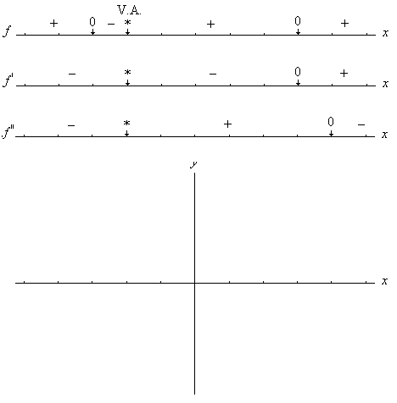

(4 pts) Find the derivative of  (simplification is optional)

____________________________________________________

(6 pts) Given the graph of *f* (*x*), carefully complete the sign diagrams of the function and its first and second derivatives.

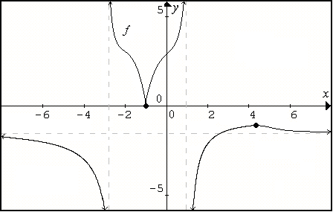

Complete the sign diagrams. Be especially careful on the second derivative.

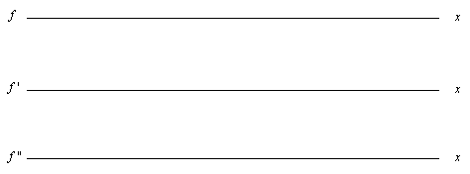

(6 pts) A study showed that, on average, the productivity of a Math 148 student after *t* hours of homework (including homework for other classes) can be modeled by *P*(*t*) where *P* is the number of problems completed per hour.

a.) Using calculus, find all extremes of , 

.

b.) Carefully sketch a graph on the given domain.

c.) Interpret any one of the extremes found in (a.).

(12 pts)Complete two of the following three questions. Cross out the problem you do not want graded. I retain the right to grade any two problems if you do not select for yourself.

a.) Safeco Field concessions needs 450,000 Mariner hats each year. Production costs are $500 to prepare for a production run and $10 for each hat produced. Inventory costs are $2 per hat per year. Find the number of hats that should be produced in each run so that the total cost of production and storage are minimized.

b.) The demand and supply functions for a stainless steel refrigerator are

D:  and S:  respectively. Find the tax that would maximize the total tax revenue from this market.

c.) The base of a rectangular box is to be twice as long as it is wide. The volume is 256 cubic inches. The material for the top costs 2¢ per square inch and material for the sides and bottom is 1¢ cent per square inch.

Find the dimensions that will minimize the cost to produce the box.