Math 097: Intermediate Algebra
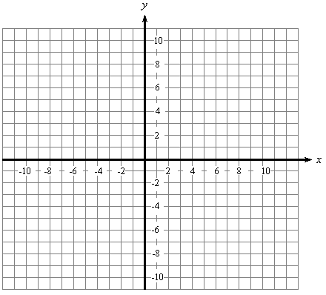
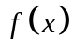
Arbitrary Functions

Consider the complete
graph of  that is given.

Use the graph to answer the following questions.
a.) 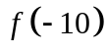 = ____________ |  | b.) 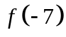 = ____________
c.) 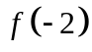 = ____________ |  | d.) 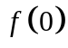 = ____________
e.) 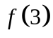 = ____________ |  | f.) 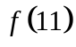 = ____________
g.) The domain of : ______________ |  | h.) The range of :________________
i.) 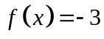 when ____________ | j.) 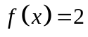 when ____________
k.) 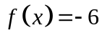 when ____________ | l.) 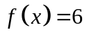 when ____________
m.) 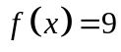 when ____________ | n.) 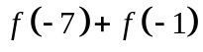 = ____________
o.) The max of is when x = ______ | p.) The min of is when x = ______
q.) 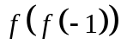 = ____________ | r.)   

