Test 1  Dusty Wilson  Math 111 – Fall 2009  No work = no credit  Closed Book & Closed Notes | Name: ________________________________  The last thing one knows when writing  a book is what to put first.  Blaise Pascal (1623 - 1662)  French mathematician

Warm-ups (1 pt each) | 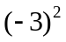= ________ | 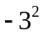= ________ | 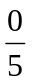= ________

1.) (1 pt) According to the quote by Pascal (see above), what is the last thing written in a book? Answer using complete sentences.

2.) (2 pts) Solve 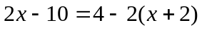 exactly.

Solution: _____________________________
3.) (2 pts) Solve 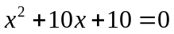 exactly.

Solution: _____________________________

4.) (2 pts) Solve 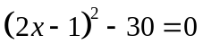 exactly.

Solution: _____________________________

5.) (2 pts) Solve the inequality 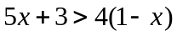. Express your answer in interval notation.

Solution: ___________________________

6.) (2 pts) Solve 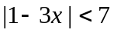. Express your answer in interval notation.

Solution: _____________________________

7.) (4 pts) Express the following expressions in the standard 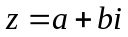 form of a complex number.

a.) (2 pts) 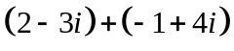

Solution: _____________________________
b.) (2 pts) 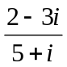

Solution: _____________________________

8.) (2 pts) Find the distance between the two points 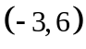 and 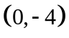.

Solution: _____________________________

9.) (2 pts) Find the equation of the line with slope 6 and y-intercept 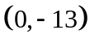. Write your answer in slope-intercept form.

Solution: _____________________________

10.) (2 pts) Find the slope and the y-intercept of the line 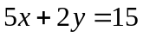

Slope: _______ and y-intercept: _______

11.) (2 pts) Find the equation of the line parallel to the line 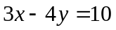 that passes through the point 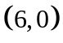.

Solution: _____________________________

12.) (1 pt) Is the function 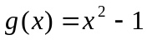 a one-to-one function? YES NO

13.) (2 pts) Given the function 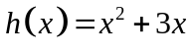, find 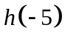

Solution: _____________________________

14.) (2 pts) Find the vertex of the function 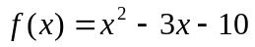.

Solution: _____________________________

15.) (5 pts) For the given graphs, clearly check “X” all that apply
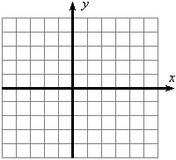  A  A | B | C
D | E | F

Clearly check “X” all that apply | A | B | C | D | E | F
a.) The line has a positive slope.
b.) The line has a non-negative slope.
c.) The line has a y-intercept of 3.
d.) The line has a slope of –.
e.) The x-intercept is 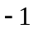.

16.) (2 pts) Given 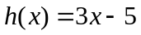, find and simplify the equation of 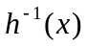.

Solution: _____________________________

17.) (2 pts) Use the given graph of g(x) to answer the following questions. Give answers in interval notation.  a.) (1 pt) What is the domain of g?  b.) (1 pt) What is the range of g? | 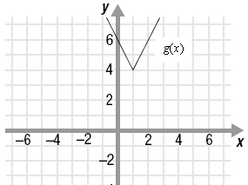
18.) (2 pts) Given 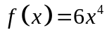 and 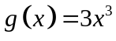, find 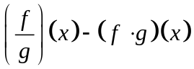

Solution: _____________________________

19.) (2 pts) Given 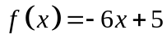 and 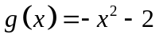, evaluate 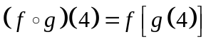

Solution: _____________________________

20.) (2 pts) The graphs of 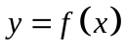 and 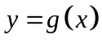 are given. Use these graphs to find 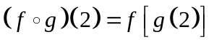  Solution: _____________________________ | 

