|  |  |
| --- | --- |
| Test 4Dusty Wilson Math 125 – Spring 2009 No work = no credit **No Symbolic Calculators** | **Name**: ________________________________  [*It is not worth an intelligent man's time to be in the majority. By definition, there are already enough people to do that.*](http://www.quotationspage.com/quote/815.html)  G.H. Hardy (1877 - 1947)  English mathematician |

|  |  |  |  |
| --- | --- | --- | --- |
| Warm-ups (1 pt each) | = ____ | = ____ | = ____ |

(1 pt) Paraphrase the quote by Hardy (see above). Use complete sentences.

(10 pts) Determine whether the integral converges or diverges. Evaluate the integral if it converges.

(10 pts) Consider the definite integral .

1. (2 pts) Evaluate the definite integral using the Fundamental Theorem of Calculus. Hint: the answer is .
2. (8 pts) Evaluate  by using Simpson’s Rule with  to find an approximation for  (to 9 decimal places, ). What is the exact error to 9 decimal places in your approximation (error = abs(exact value – approximate value))?

#### Approximation: ______________________________

#### Exact error: ______________________________

(10 pts) Use the comparison test to determine whether  converges or diverges. Make sure you clearly state your conclusion.

(10 pts) How large do we have to choose *n* so that the approximation  using Simpson’s Rule to  has an error bound smaller than 0.00001? Use the given graph to estimate the coefficient *k* in the error bound.

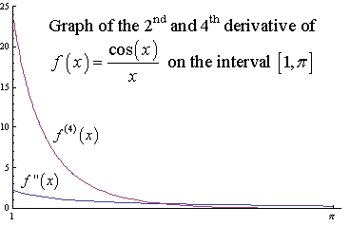

(15 pts) Consider the curve  on the interval .

1. Set up an integral representing the arc length of the curve. Do not evaluate the integral.
2. Set up an integral representing the surface area of the surface formed by rotating the curve about the *x*-axis. Do not evaluate the integral.
3. Set up an integral representing the surface area of the surface formed by rotating the curve about the vertical line . Do not evaluate the integral.

(10 pts) Derive the circumference of a circle with radius *r* by finding the arc length of the appropriate function and using symmetry (where necessary).