Complete the following problems. All partners should work together, and all are responsible to make sure that each problem is done correctly. Do not get help from other groups, and you must show your work to get full credit.

1. Find the degree of each vertex in the following graphs.

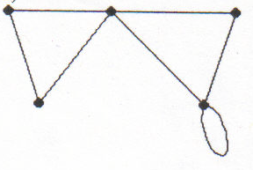 | 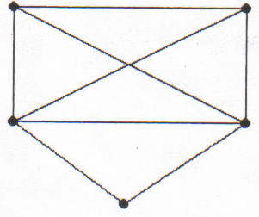 | 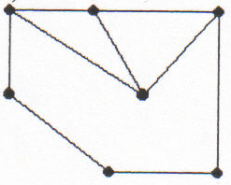
(a.) | (b.) | (c.)

2. In problem (1.), why does (a.) above have an Euler circuit while (b.) and (c.) do not?

3. Optimally eulerize the following graphs.

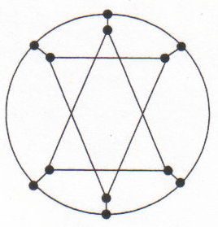 | 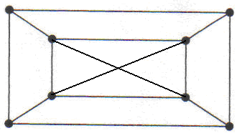

4. Show an Euler circuit for the following graph by drawing numbered arrows along the edges.

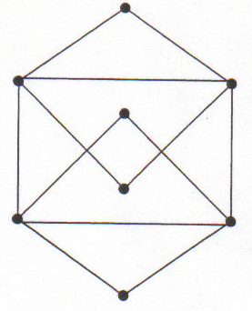

5. The following diagram shows a river with four islands with nine bridges connecting the islands and the shores.

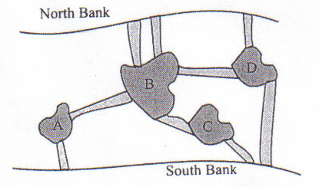

a) In order to draw a graph to represent the diagram above, what do the vertices represent and what do the edges represent?

b) Draw a graph to represent the above diagram.

c) Does the graph have either an Euler circuit or an Euler Path? Why or why not?

6. Can a graph have a circuit but no Euler circuit? Use a diagram to explain your answer.

7. Do you think a graph containing a bridge can have an Euler circuit? Use a diagram to explain your answer. Identify the bridge.

8. Draw a graph which has

a) 6 vertices, 4 of which have degree 3. b) 5 vertices and exactly one bridge and one circuit.

c) 6 vertices and has an Euler circuit d) 6 vertices and has an Euler path
but no Euler circuit.

