Math 115
Dusty Wilson
Set Notation

Sets and Intervals

In the discussion that follows, we need to use set notation. A set is a collection of objects, and these objects are called the elements of the set. If S is a set, the notation 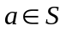 means that a is an element of S, and 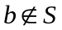 means that b is not an element of S. For example, if Z represents the set of integers, then 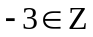 but 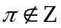.

Some sets can be described by listing all their elements within braces {curvy brackets}. For instance, the set A that consists of all positive integers less than 7 can be written as

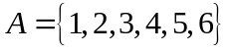

We could also write A in set-builder notation (or set notation) as

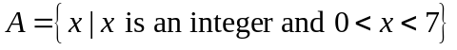

which is read “A is the set of all x such that x is an integer and 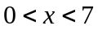.”

If S and T are sets, then their union 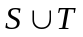 is the set that consists of all elements that are in 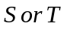 (or in both). The intersection of S and T is the set 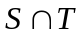 consisting of all elements that are in both S and T. In other words, is the common part of S and T. The empty set, denoted by 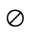, is the set that contains no element.

Example 1: Union and Intersection of Sets

If 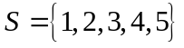, 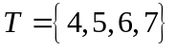, and 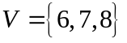, find the following sets a.) , b.) , and c.) 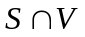.

Solution

 | a.) 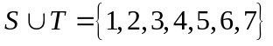 |  | All elements of S or T
 | b.) 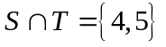 |  | Elements common to both S and T
 | c.) 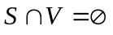 |  | S and V have no element in common

Certain sets of real numbers, called intervals, occur frequently in Precalculus and correspond geometrically to line segments. For example, if 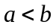, then the open interval from a to b consists of all numbers between a and b and is denoted by the symbol 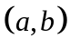.

Using set-builder notation, we can write: 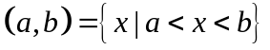

Note that the endpoints, a and b are excluded from this interval. This fact is indicated by the parentheses 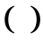 in the interval notation and open circles should we graph the interval on the number line.

The closed interval from a to b is the set: 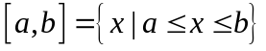

Here the endpoints of the interval are included. This is indicated by the square brackets 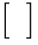 in the interval notation and solid circles should we graph the interval on the number line. It is also possible to include only one endpoint in an interval, as shown in the table of intervals that follows.

We also need to consider infinite intervals such as

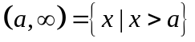

This does not mean that (“infinity”) is a number. The notation 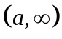 stands for the set of all numbers that are greater than a, so the symbol simply indicates that the interval extends indefinitely far in the positive direction.

In set notation, the statement is read, “the set of all x’s such that x is greater than a.”

The following table lists the nine possible types of intervals. When these intervals are discussed, we will always assume that .

Interval Notation | Set Notation | Number Line
 | 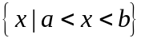
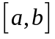 | 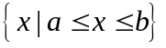
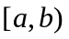 | 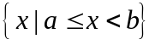
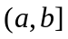 | 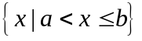
 | 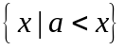
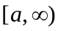 | 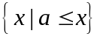
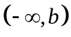 | 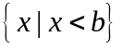
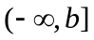 | 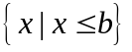
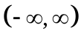 | R (the set of all real numbers)

Example 2: Writing intervals in set notation

Express each graphed region as an interval and the express the result in set notation.

Solution
Number Line | Interval Notation | Set Notation
 | 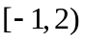 | 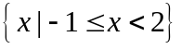
 | 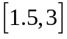 | 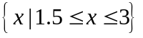
 | 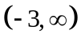 | 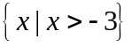

Example 3: Finding Unions and Intersections of Intervals

Graph each set: a.) 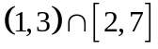 and b.) 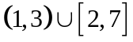

Solution
a.) The intersection of two intervals consists of the numbers that are in both intervals. To find the intersection, graph both sets and find the overlap.

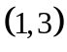
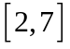

In set notation, the solution is 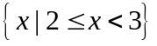 which is read, “the set of all x’s such that two is less or equal to x which is less than three.”

b.) The union of two intervals consists of the numbers that are in either one interval or the other (or both). To find the union, graph both sets and find all points shaded.

In set notation, the solution is 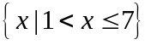 which is read, “the set of all x’s such that one is less than x which is less or equal to seven.”

Set notation and the Domain of a Rational Function

Does the cost-benefit model 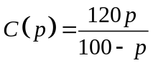 indicate that the city can clean up its lake completely? To do this, the city must remove 100% of the pollutants. The problem is that the rational function is undefined for 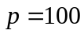 (why?).

The domain of a rational function is the set of all real numbers except those for which the denominator is zero. We can find the domain by determining when the denominator is zero. For the cost-benefit model, the denominator is zero when (i.e., when we try to remove 100% of the pollutants). Furthermore, for this model, negative values of p and values of p greater than 100 are not meaningful (who says math isn’t touchy-feely?). The domain of the function is 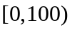 and excludes 100.

As this is a discussion of set notation, we write the domain as 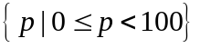 which is read as, “the set of all p’s such that zero is less or equal to p which is less than 100.”

Inspection can sometimes be used to determine the domain of a rational function.

Example 4: Domains of rational functions by inspection.

Find the domain of a.) 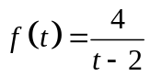 and b.) 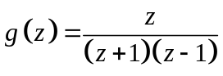.

Solution
a.) The denominator of the function is zero when 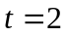. So, the domain is the set of all t’s such that t is a real number and 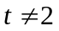.

Hold on! We can write that statement in set notation as 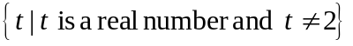. Abbreviating the statement “t is a real number” with the statement “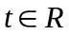”, our solution simplifies to: 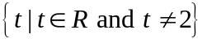.

b.) The denominator of the function is zero when 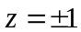. So, the domain is the set of all z’s such that z is a real number and 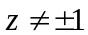. That is, 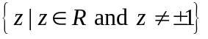.

Adapted from Precalculus: Mathematics for Calculus, 4th, Stewart, Redlin, and Watson, 8 – 10.
Adapted from Intermediate Algebra for College Students, 3rd ed. Blitzer, 371 – 2.
In interval notation, the domain would be written as: 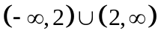.
In interval notation, the domain would be written as: 

