Review for Test 1
Math 125: Calculus II

I have decided to spend an extra day reviewing and let you figure the three problems in 6.5 out on your own. We will review one day, and then come back and do the section on work.

Format
- The exam will contain 10 problems (plus or minus 3) and will last 50 minutes.
- It is a paper and pencil exam.
- You will need to show your work.
- You may use a graphing calculator. However, you may not use a symbolic calculator such as the TI-89.

Basic Content.
- You are responsible for sections 5.1 – 6.5.
- In addition to the material covered in the class, you are responsible for all of the basic facts you have learned since kindergarten. These include the facts that George W. Bush is the President of the United States of America, 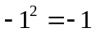, and that 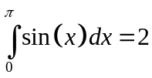.
In Studying . . .
- You should be able to recreate every proof done in class.
- You should be able to solve every example done in class.
- You should be able to solve every quiz question.

A Summery of the Topics.

Section 5.1: Areas and Distance
- 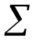notation.
- Approximating areas using rectangles.
  - Right end-points
  - Left end-points.
  - Midpoints.
- Finding the exact area using an infinite number of rectangles.
- The relationship between the area under the curve and the distance problem.

Section 5.2: The Definite Integral
- The Definition of a Definite Integral (The Riemann Sum).
- Positive and negative “area” under a curve.
- The properties of summations.
- Setting up the Riemann Sum given a definite integral. This includes finding 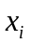, 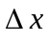, and 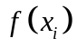.
- The properties of integrals.
- The comparison properties of integrals.

Section 5.3: The Fundamental Theorem of Calculus
- The FToC1.
- Using FToC1 to find derivatives.
- The FToC2.
- The proof of the FToC2.
- Using the FToC2 to evaluate definite integrals.

Section 5.4: Indefinite Integrals and the Total Change Theorem
- Indefinite integrals.
- Definite integrals.
- The total change theorem.

Section 5.5: The Substitution Rule
- The substitution rule for indefinite and definite integrals.
- Integrals of Symmetric Functions

Section 6.1: Areas Between Curves
- Find the area between curves in terms of x and y.

Section 6.2: Volumes
- Set-up integrals to find volumes of rotation using disks and washers.
- Understand how to find disks and washers regardless of the axis of rotation.
- Set –up volumes to find volumes of “ugly” critters – usually using “disks.”
- Note: You will have the use of a non-symbolic graphing calculator – although you should be able to do any graphing without a calculator.
- Note: You will need to set-up integrals, however I will not ask you to find the volume.

Section 6.3: Volumes by Cylindrical Shells
- Set-up integrals to find volumes using the shell method.
- Know how and when to use the shell method.

Section 6.4: Work
- Understand and be able to work with the units of work.
- Be able to set up the integral used to find the work associated with a process.

Section 6.5: Average Value of a Function
- Understand how to calculate the average value of a function.

Practice Problems:

Estimate 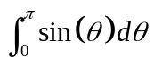 using 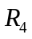. Give an exact answer (not a decimal approximation).

Use the definition of the definite integral to calculate 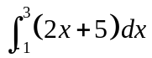.

Evaluate the indefinite integral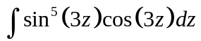.

A car speeds up at a constant rate from 10 to 70 mph over a period of half an hour. Its fuel efficiency (in miles per gallon) at various speeds is shown in the table. Make left, right, and midpoint estimates of the quantity of fuel used during the half hour. Round to four decimal places.

Speed (mph) | 10 | 20 | 30 | 40 | 50 | 60 | 70
Fuel efficiency (mpg) | 15 | 18 | 21 | 23 | 24 | 25 | 26

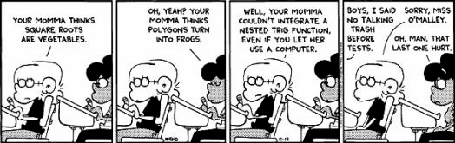

Evaluate the definite integral 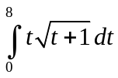, if it exists.

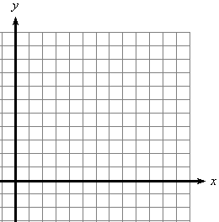
Let 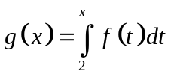 on 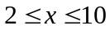 for the function  portrayed in the given graph. Given what you know, sketch a graph of 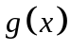 on the interval.

Find the volume of the solid obtained by rotating the region bounded by 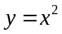 and 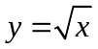 about the line 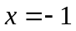

Find the volume of the solid formed in the following manner. The elliptical region with boundary curve 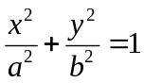 is intersected with circular cross-sections perpendicular to the ellipse. The diameter of each circular cross-section is in the plane of the ellipse.

Find the volume of the solid obtained by rotating the region bounded by and 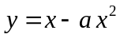 (when 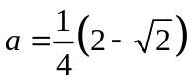) on 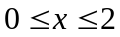 about the x-axis.

Evaluate the integral in terms of a. Verify the volume is 

